salesforce certified integration architecture designer
1. which three ways can production data be moved.
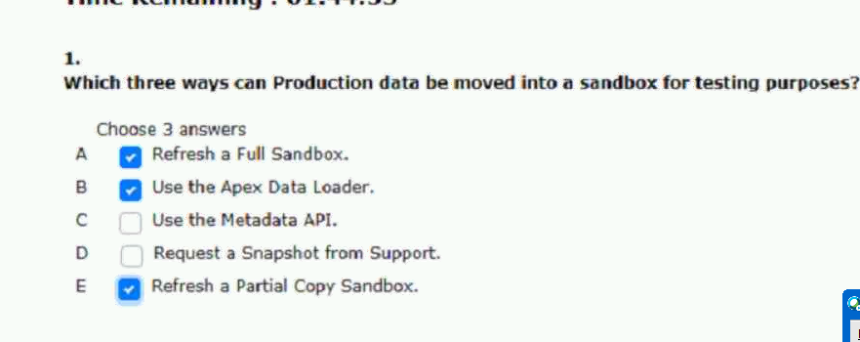
2.universal containers (uc) uses salesforce to create and manage accounts and opportunities.
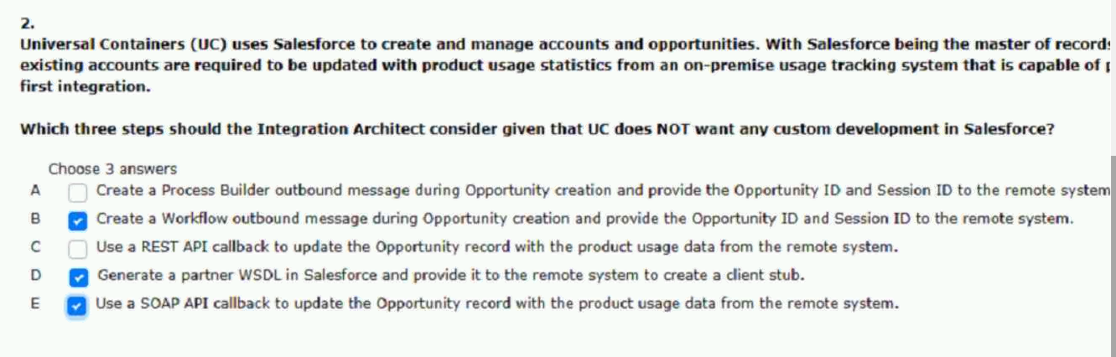
3.universal containers would like to send all the closed opportunity records.
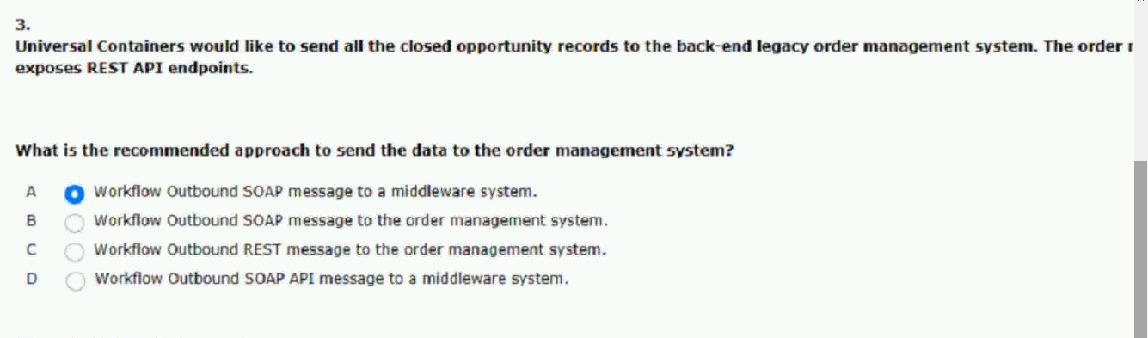
4.universal containers has chosen salesforce einstein analytics as their analytics platform.
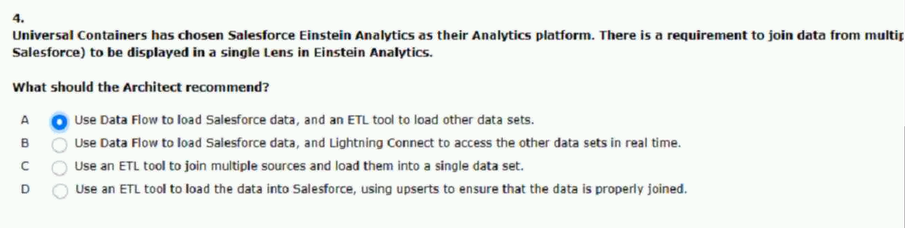
5.universal containers (uc) merges with planetary shipping.
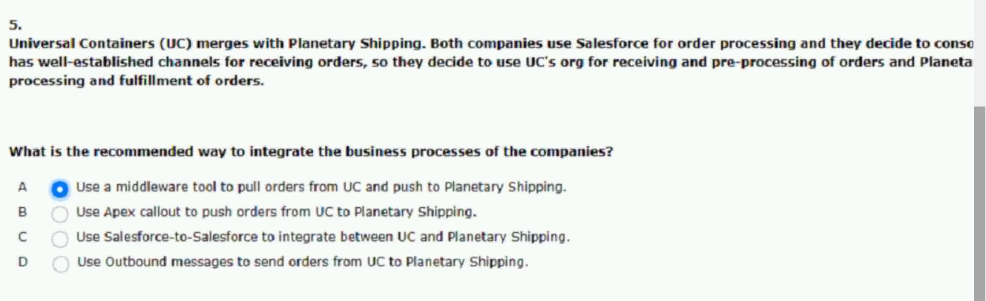
6.which two considerations of apex REST services should an integration.
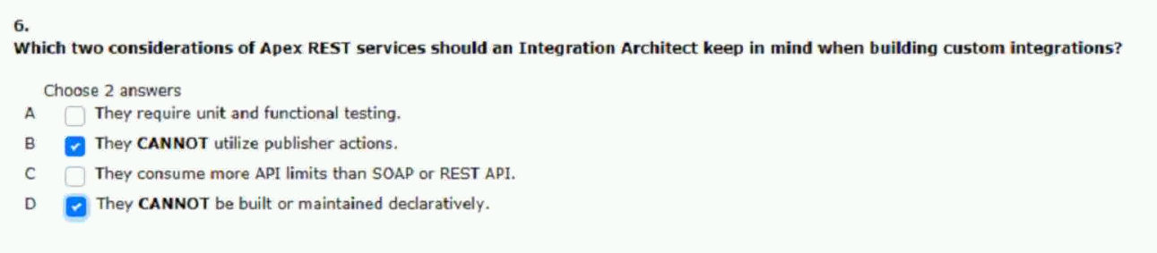
7.universal containers has two integrations to salesforce.
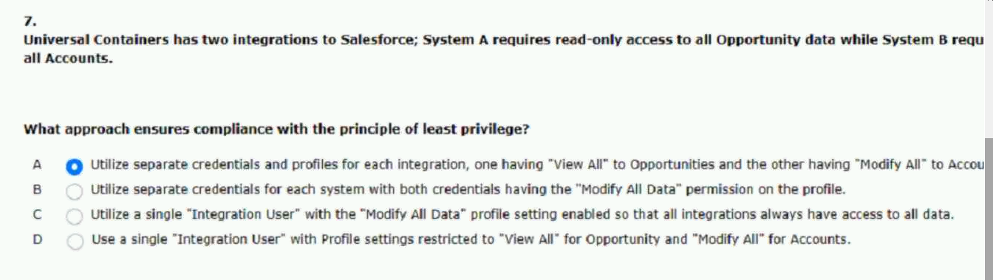
8.asystem at universal containers needs to update opportunity details.
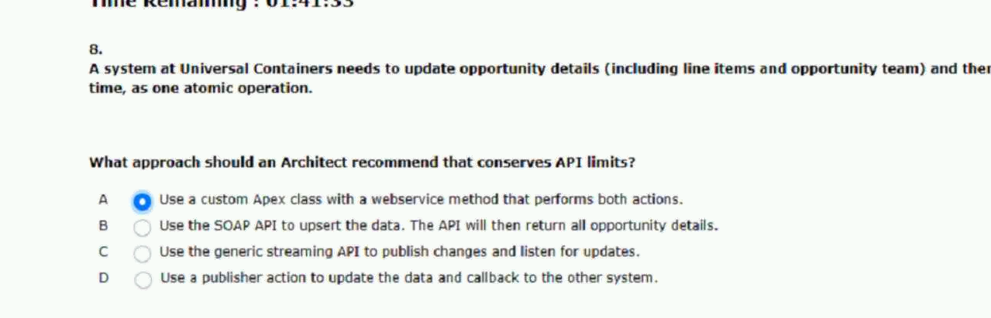
9.universal containers is hearing complaints from users that.
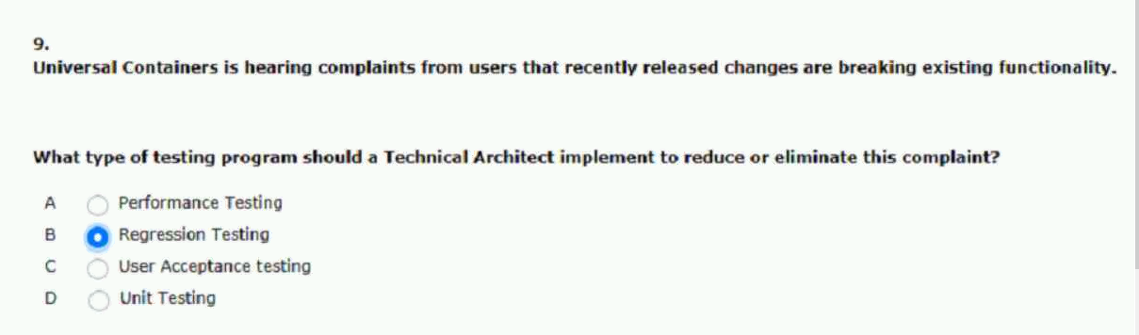
10.universal containers is building an integration between their instance.
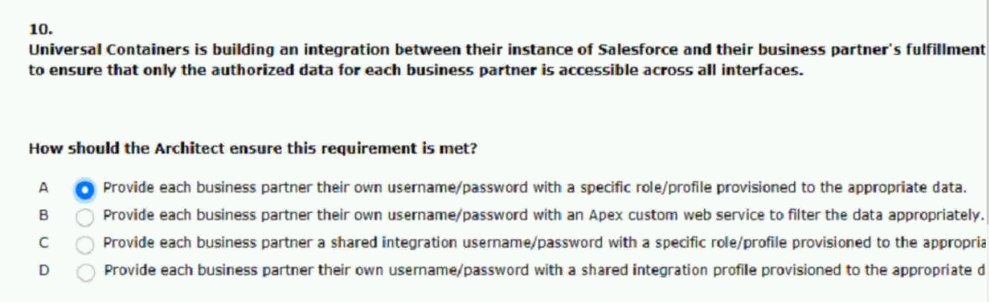

11.universal containers would like to ensure that the server and client.
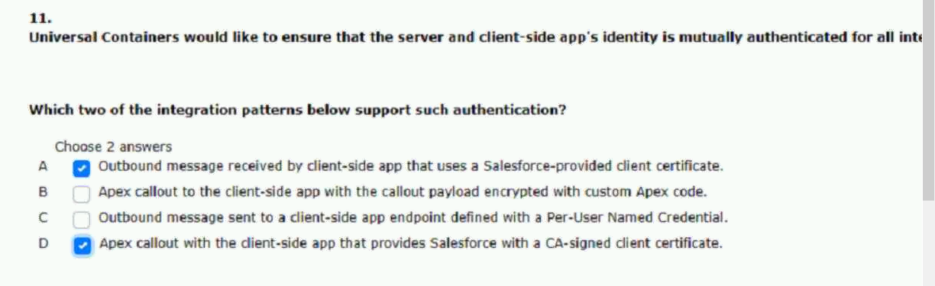
12.uc leverages customers MDM as a source of truth.
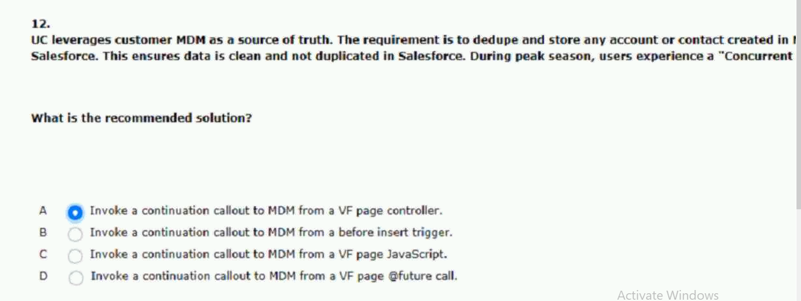
13.universal containers is integrating their salesforce platform with their.
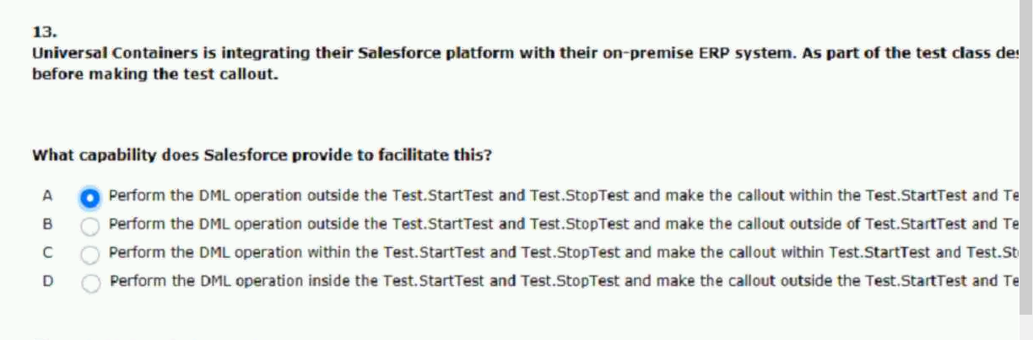

14.whic two benefits should an integration architect consider when.
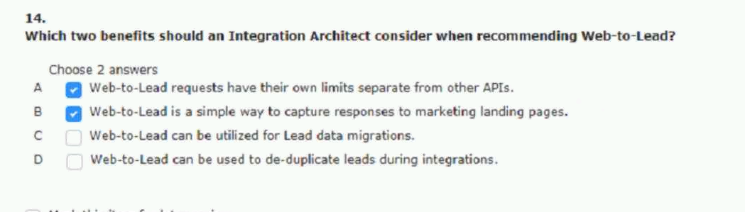
15.universal containers (UC) uses several systems as part of their enterprises.
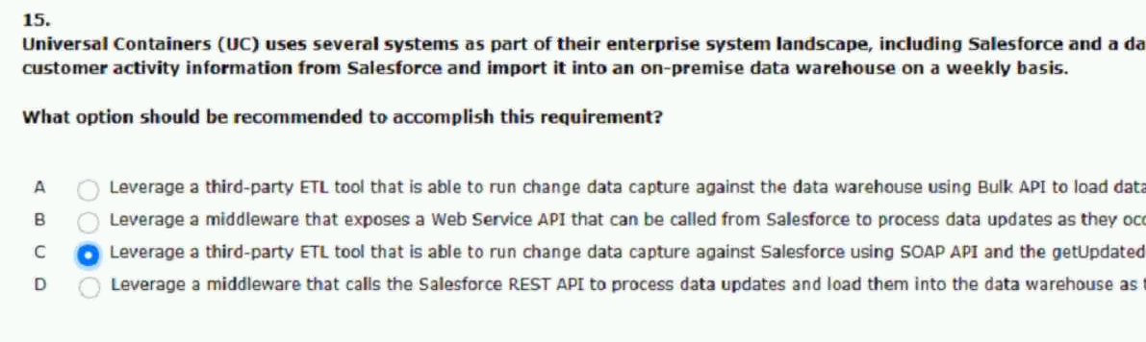
16.what are two benefits of named credentials
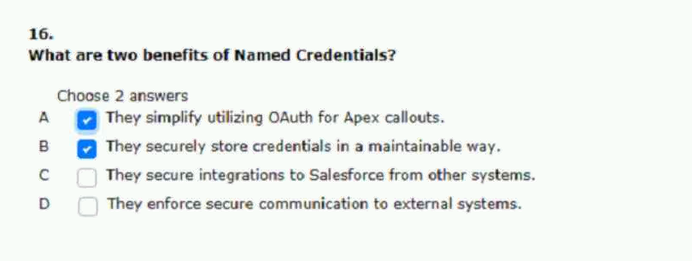

17.universal containers is planning a data migration into salesforce and must.
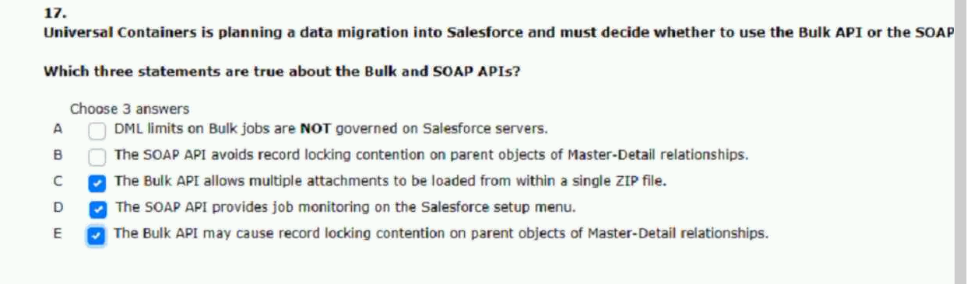
18.universal containers (uc) ships millions of orders per year and releases.
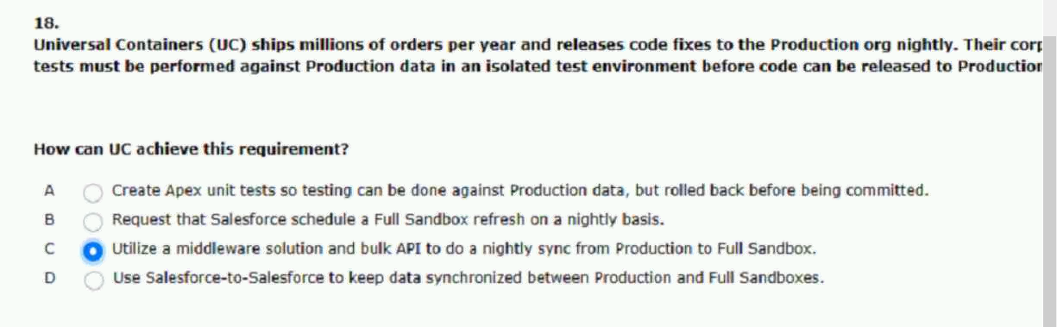
19.universal containers (uc) has a batch integration that runs every five.
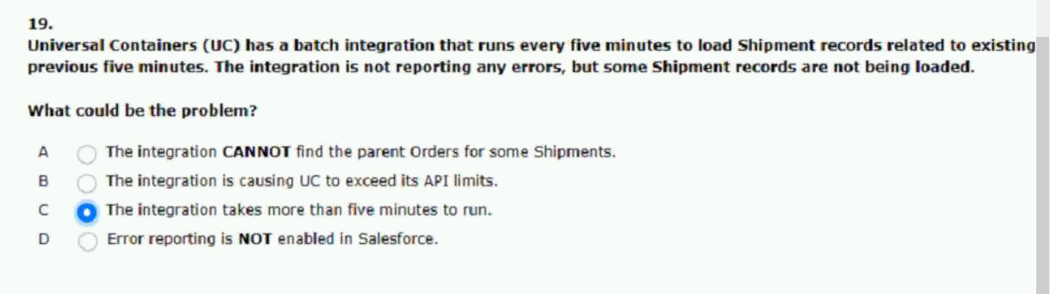

20.universal containers (uc) has an ERP application where all customer orders are stored.
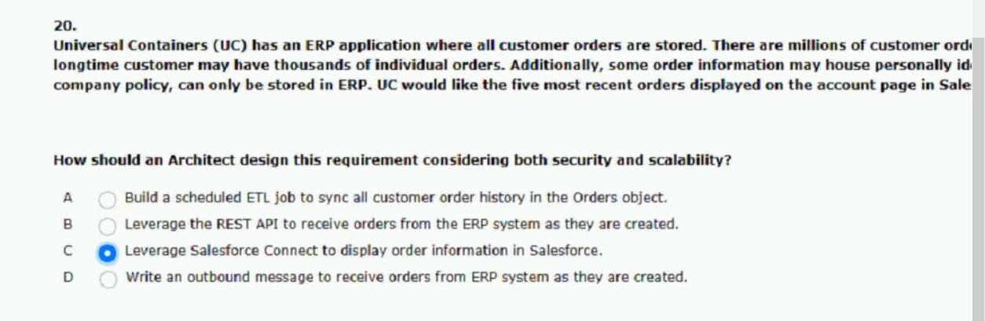
21.in order to avoid slowing down inbound call center sales agents.
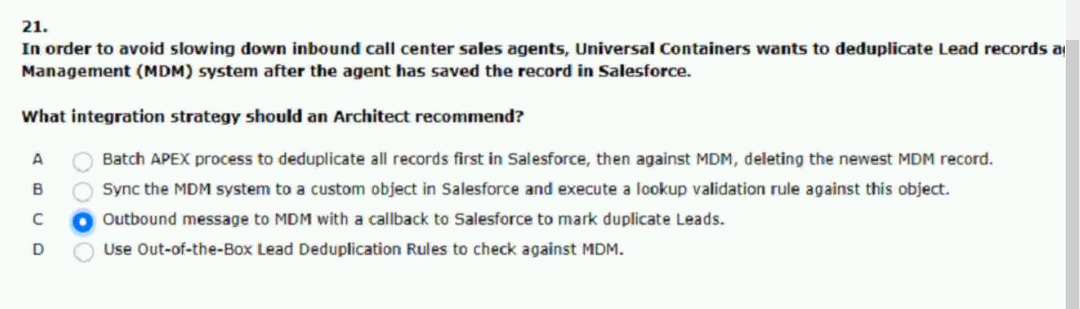
22.universal containers needs to integrate salesforce with several home.
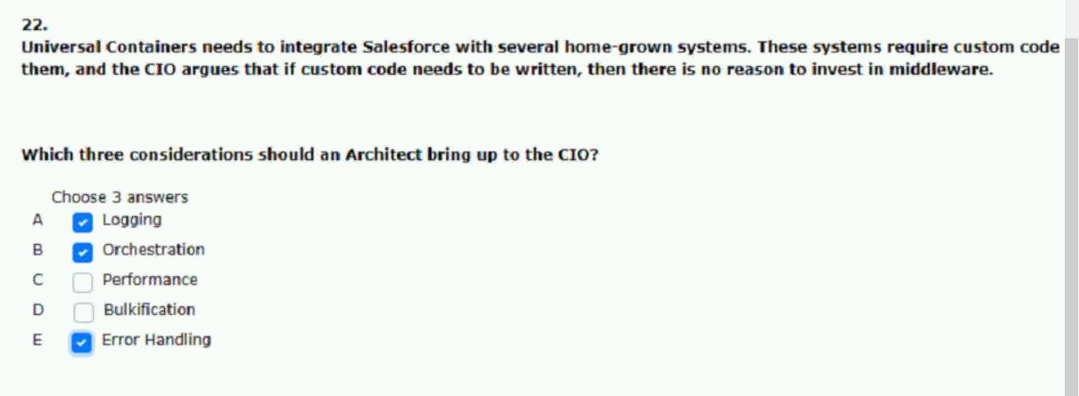

23.universal containers acquires planetary shipping and decides to migrate all customer.
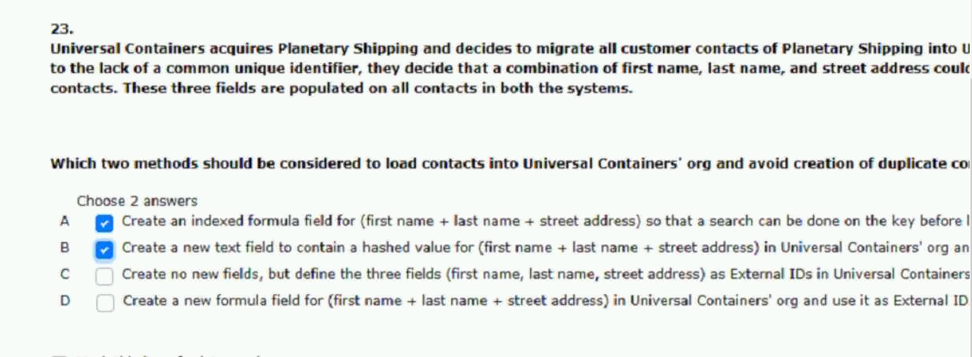
24.universal containers (uc) has salesforce integrated with their mainframe.
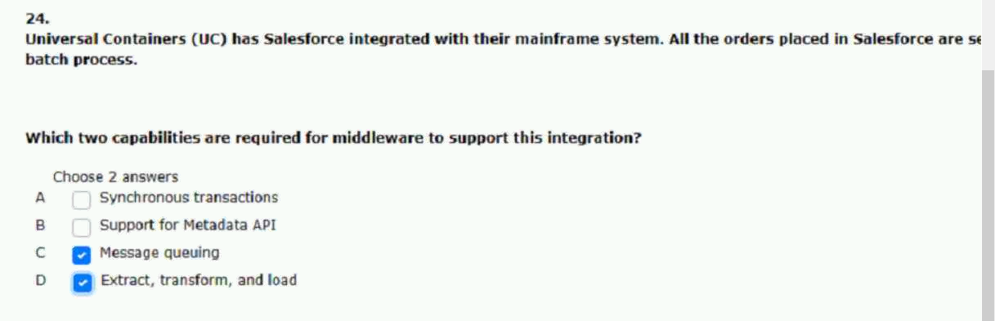
25.universal containers (uc) has many batch apex jobs scheduled to perform.
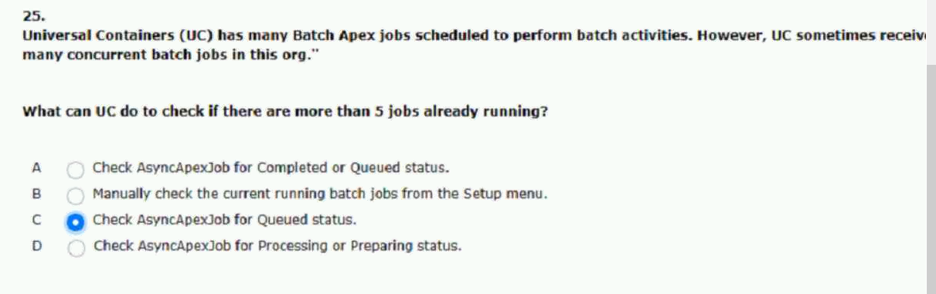

26.customer support raps at universal containers (uc) work on a case record in.
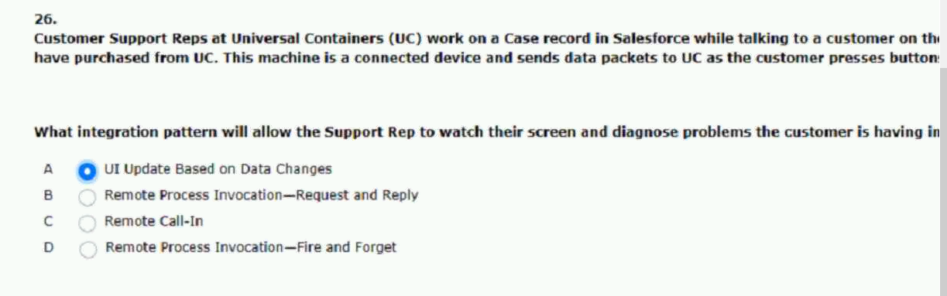
27.universal containers (uc) wants to connect their on-premise.
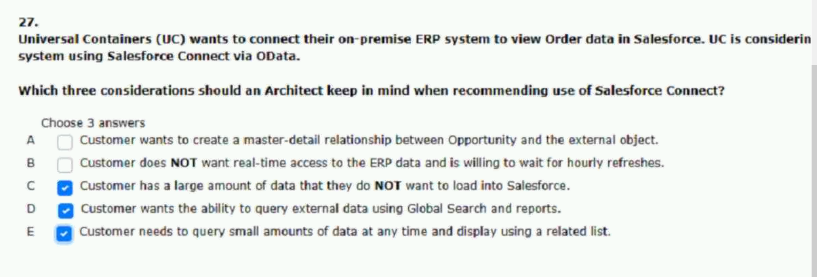
28.universal containers has decided that they will be using.
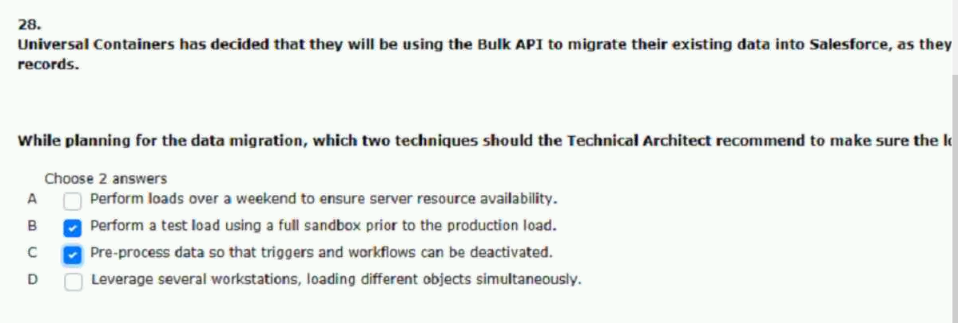

29.universal containers has a SOAP-based integration that runs nightly to update the product.
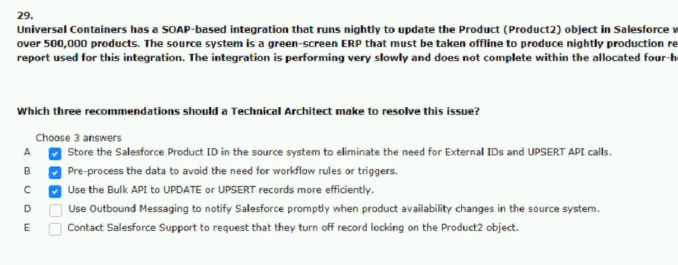
30.universal containers (uc) is planning to roll out a new lightning platform app to a regional business.
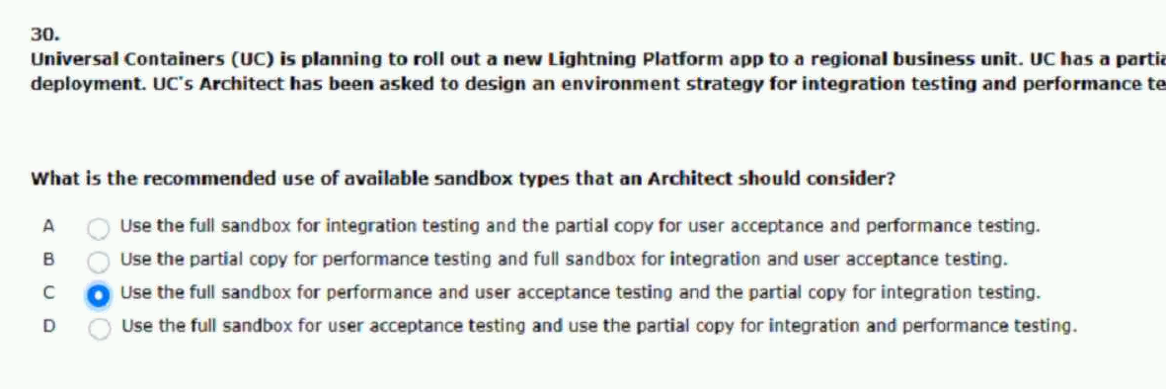
31.universal containers has a custom visualforce page that makes a callout to an.
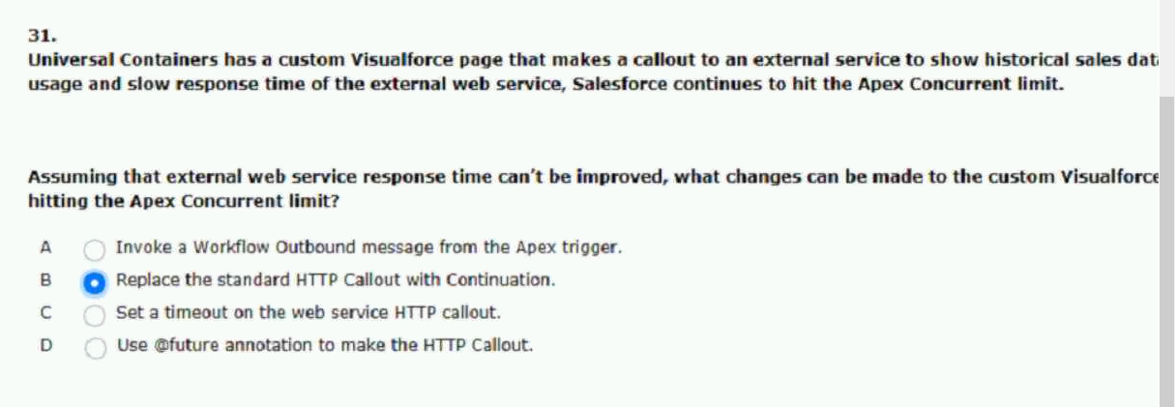

32.what salesforce technology should an integration architect consider when needing.
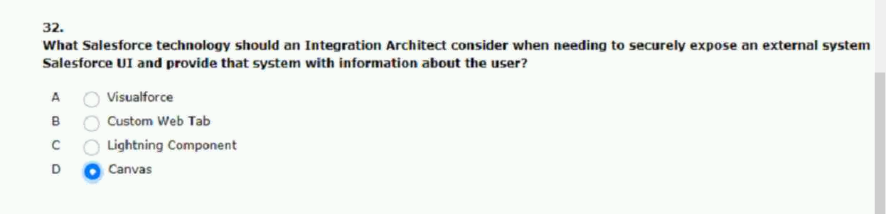
33.which two statements are correct about external IDs?
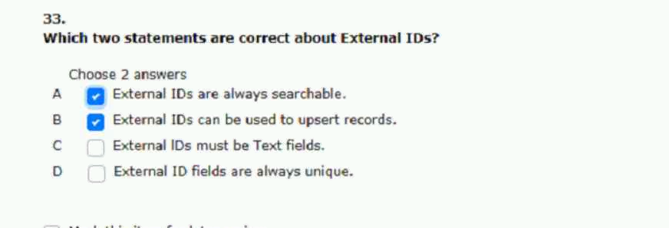
34.which two automated methods should an architect use.
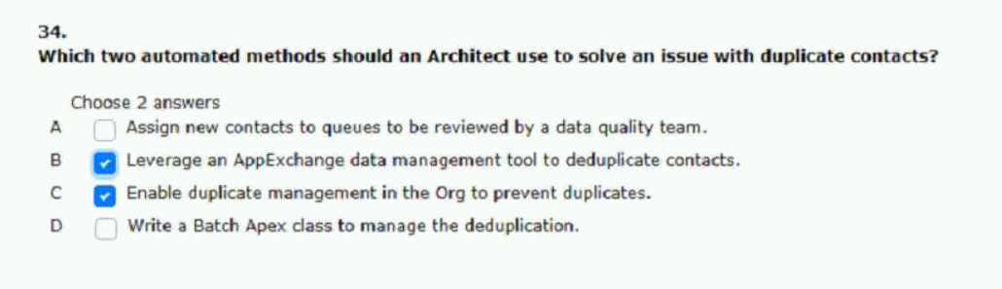

35.universal containers (uc) would like to provide near.
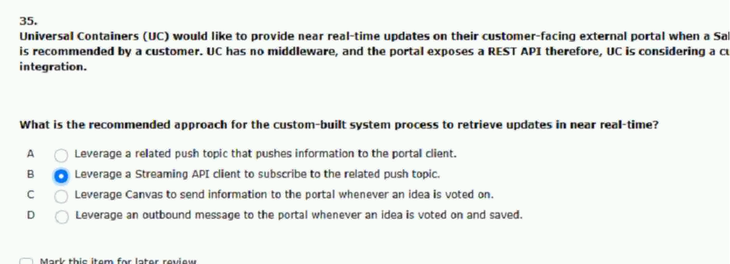
36.universal containers is building an integration from their
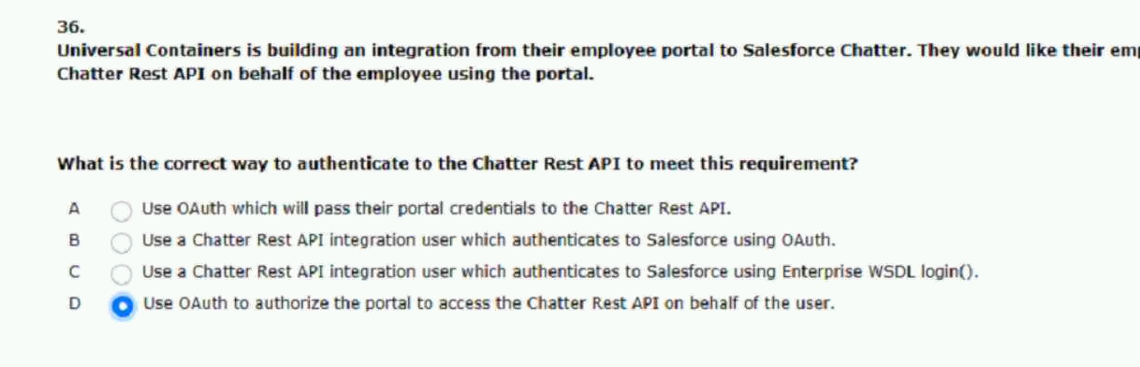
37.universal containers has a simple on-premise.
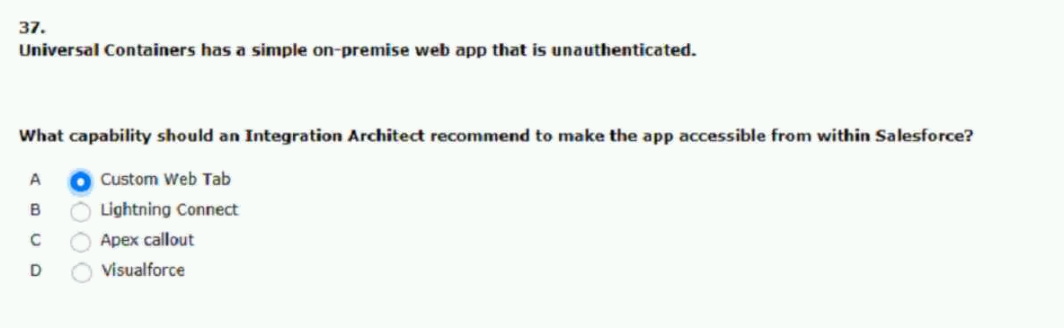

38universal containers (uc) user several systems as part.
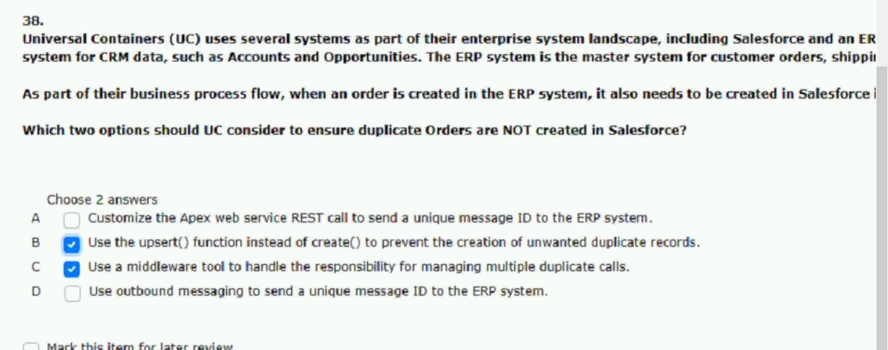
39.universal containers is building an integration between salesforce.
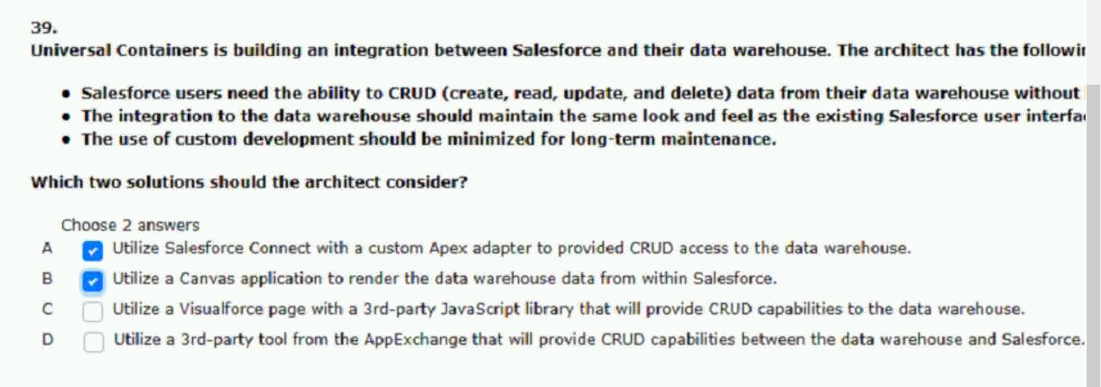
40.universal containers wishes to validate street addresses in salesforce.
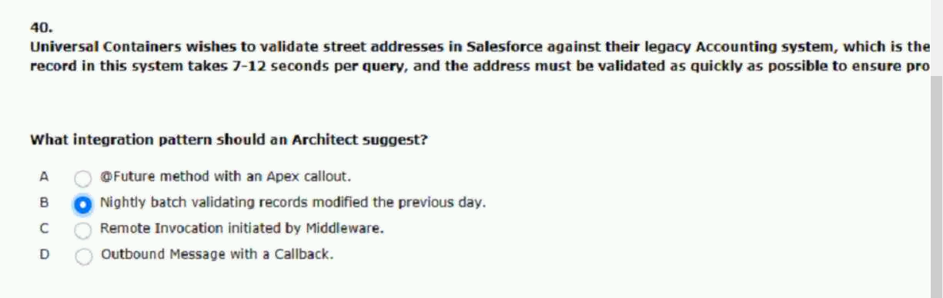

41.what are three capabilities of the bulk API
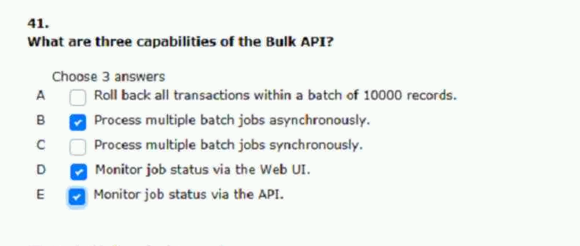
42.universal containers (uc) would like to integrate salesforce to their.
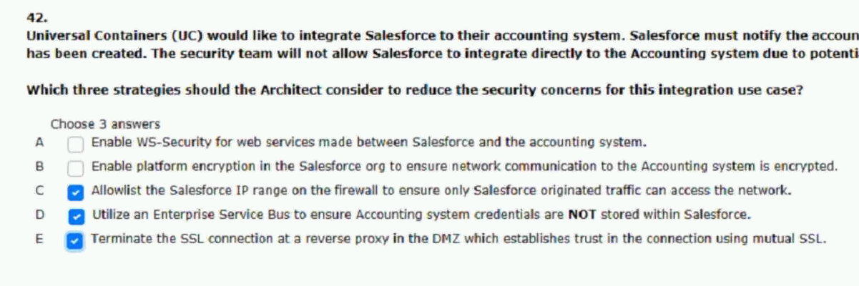

43.universal containers decided to use salesforce sales
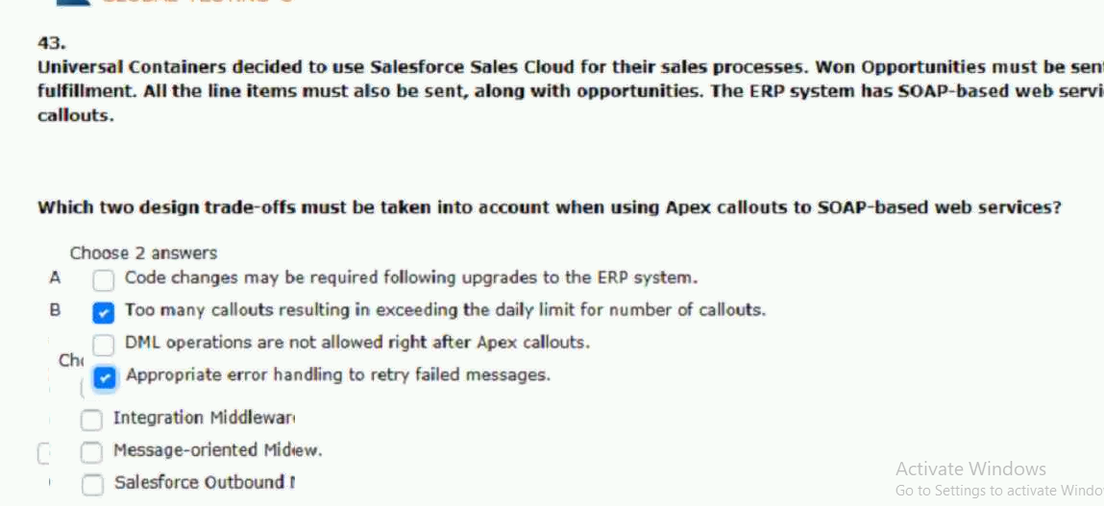
44.universal containers has logistics engineers that observe a near real-time.
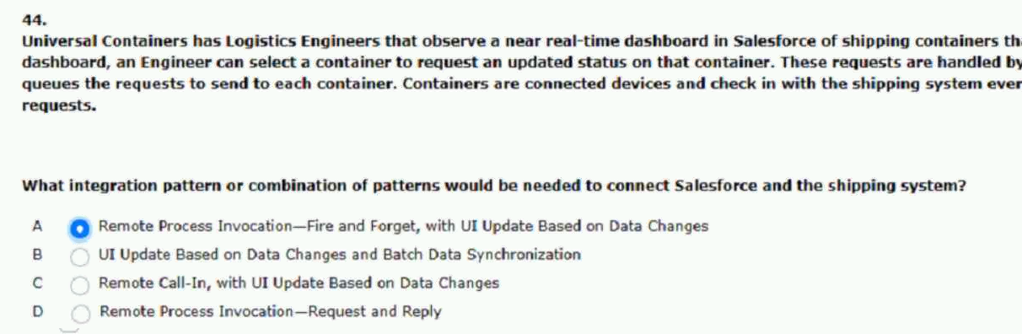
45.universal containers has a requirements to update the salesforce.
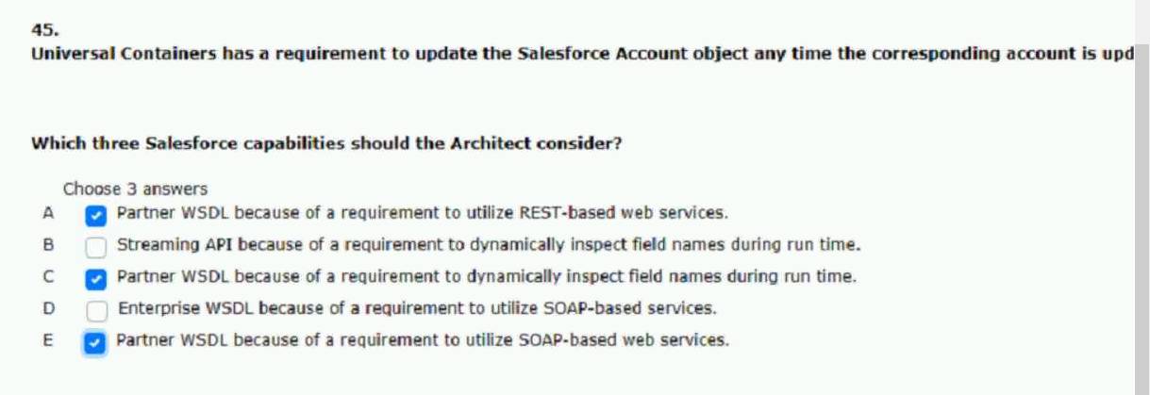
46.universal containers leverages sales cloud as their sales platform.
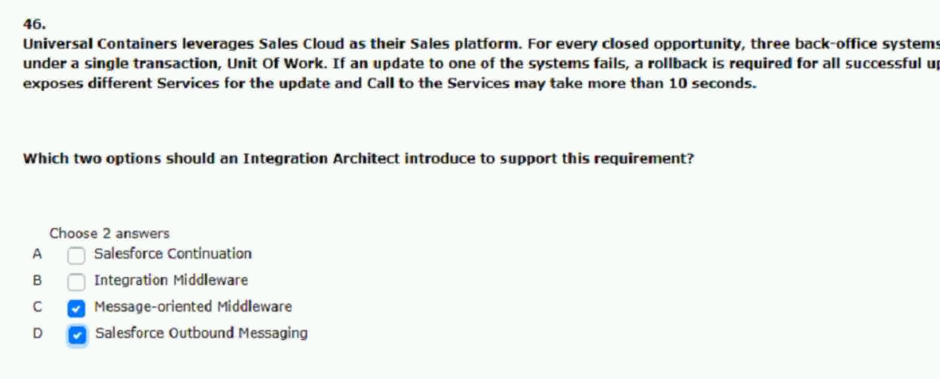
47.universal containers has a trigger on the order objects to update the.
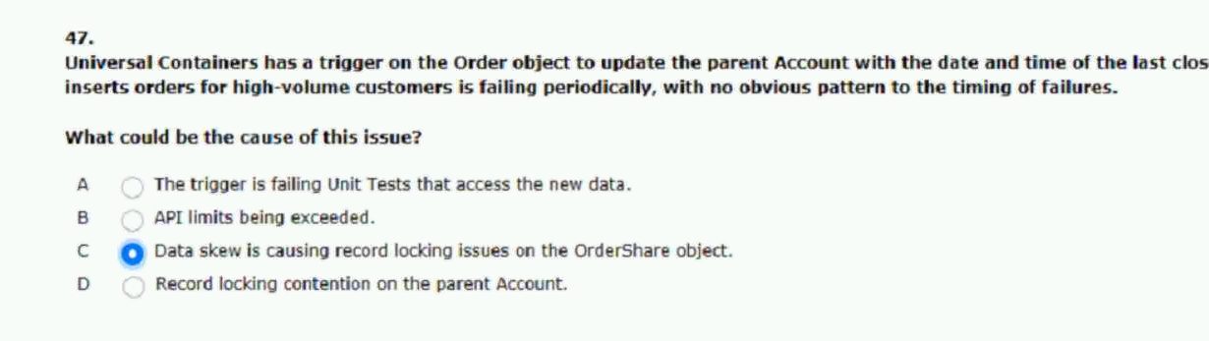
48.universal containers has an external ERP that will manage.
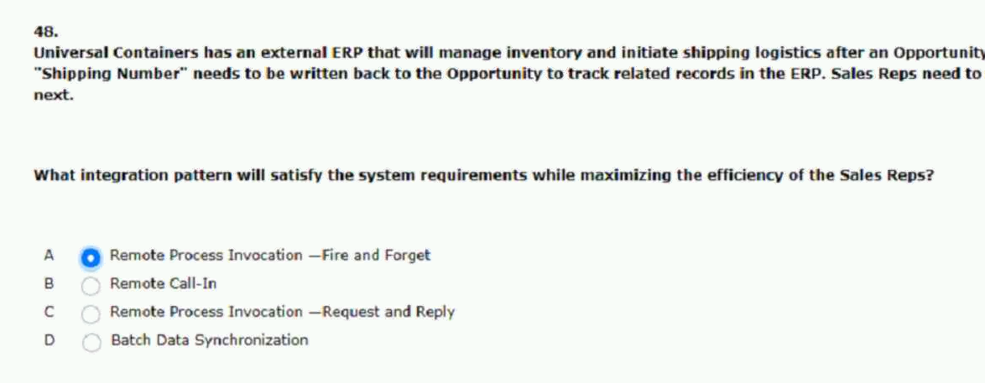

49.universal containers has a custom salesforce UI that is used.
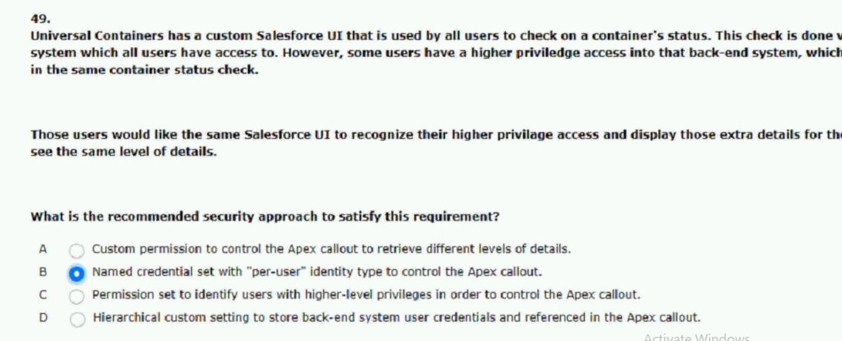
50.which two approaches should an integration architect recommend to allow access to on-premise
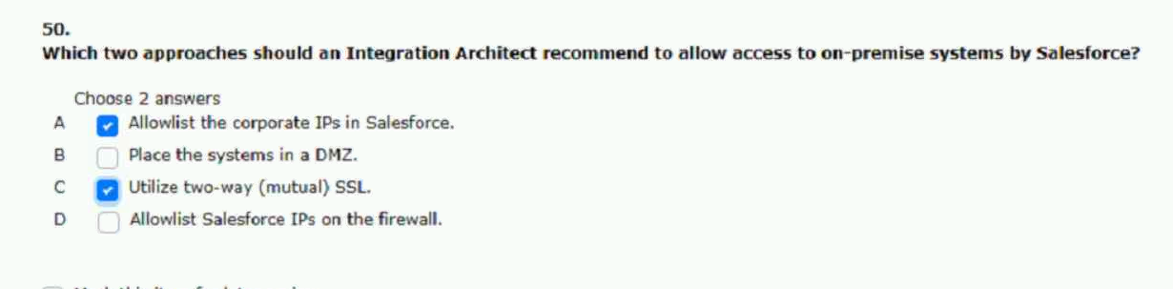
51.universal containers has complex data transformation error handling and process autoamtion
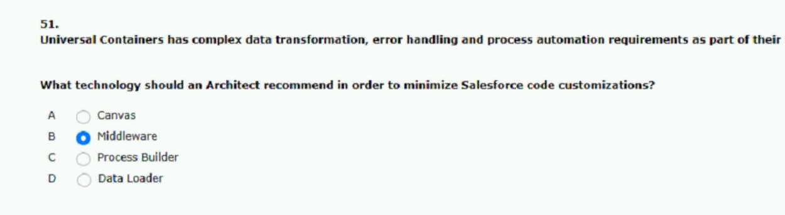

52. universal containers has a data warehouse system that collects information from upstream systems in order to do proprieta
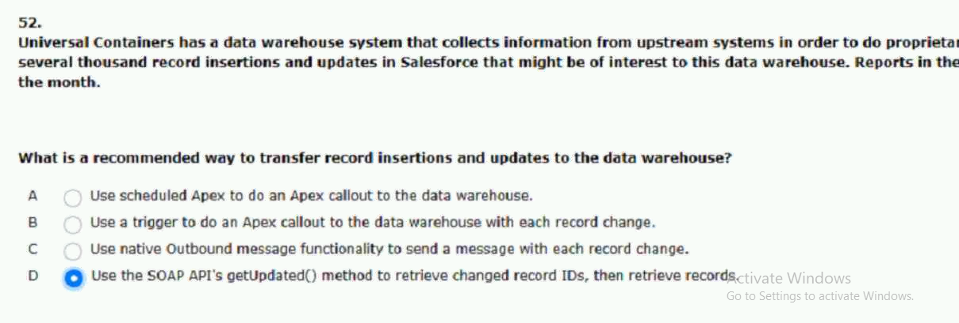
53.universal containers (uc) has data in an erp system that is critical to their service organization and how they
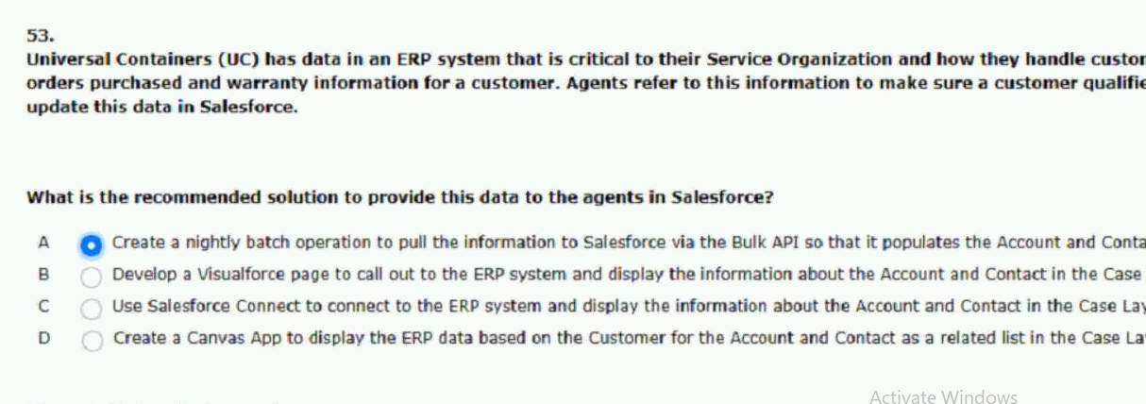
54.universal containers (uc) has decided that acquisition of other companies will be a key focus of their growth for the next
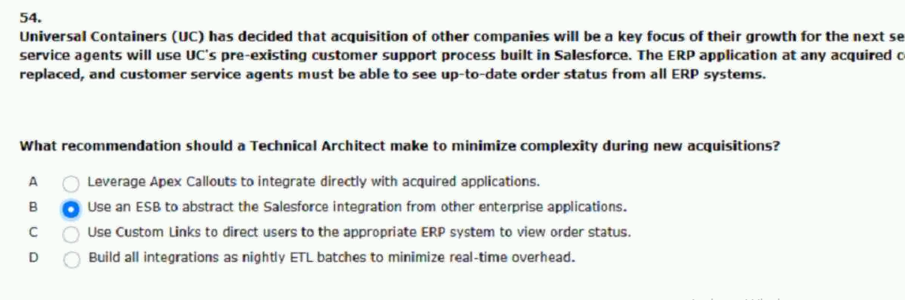

55.universal containers needs to send order details to the erp system using an apex callout to a rest api via https
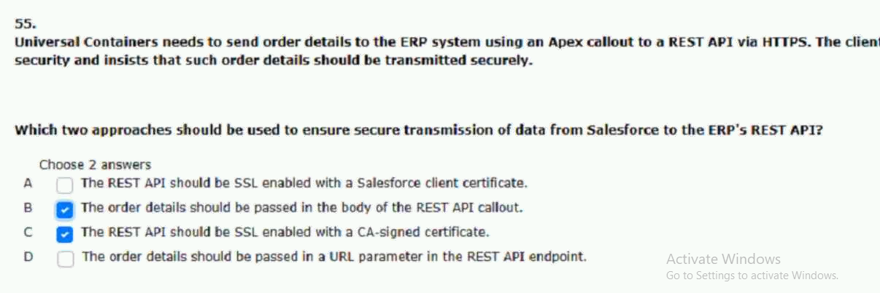

56.universal containers (uc) has einstein analytics in their salesforce org.uc has expertise and access to the dell boomi etl
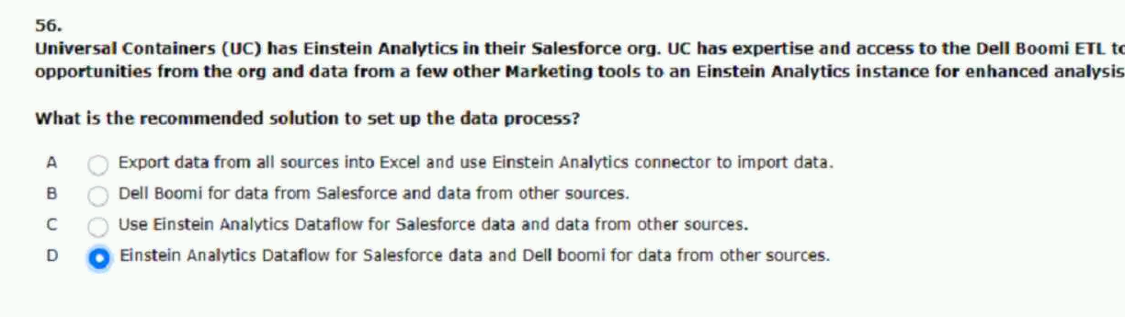

57.universal containers requires that their back office systems be reliably notified in near real-time for
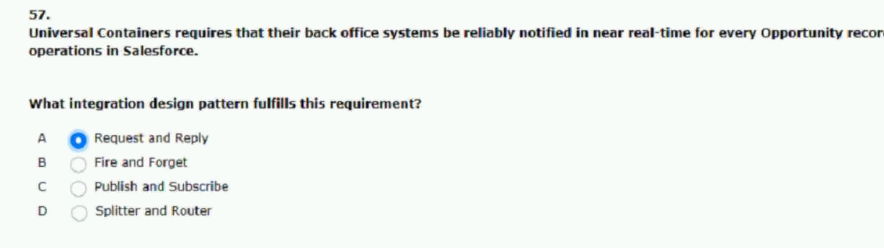

58.when a sales rep closes an opportunity in salesforce,an order should be created in universal container
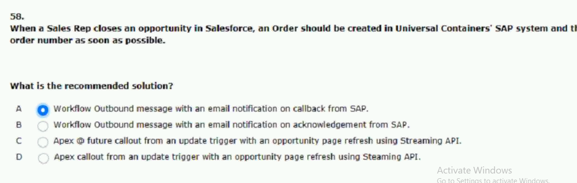

59.universal containers(uc) admin has installed a canvas app and has chosen”all users may self-authorize”
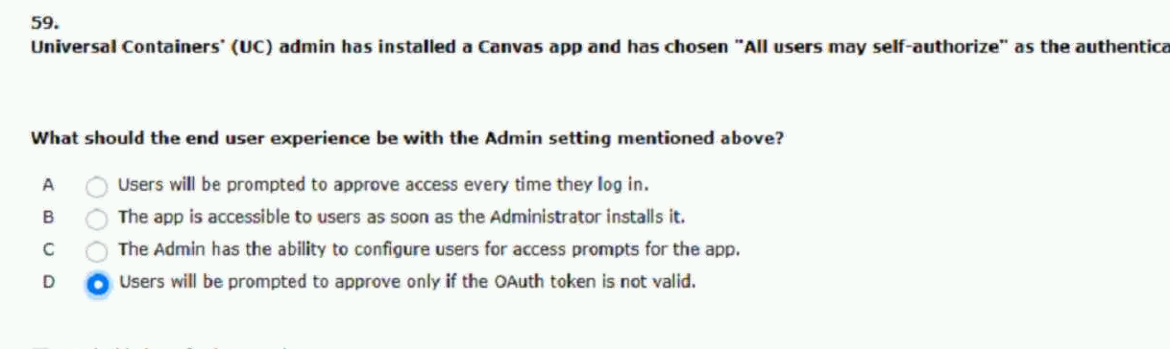
60.universal containers acquires several companies and decides to consolidate all customer service
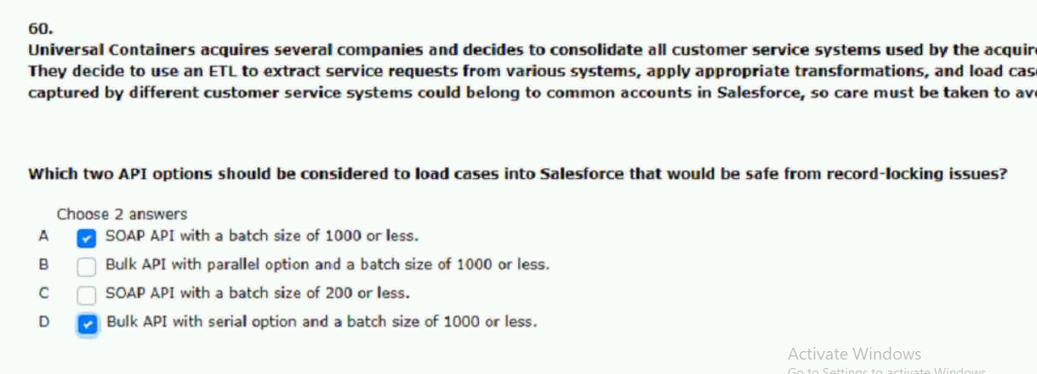
61.what salesforce technology should an integration architect consider.
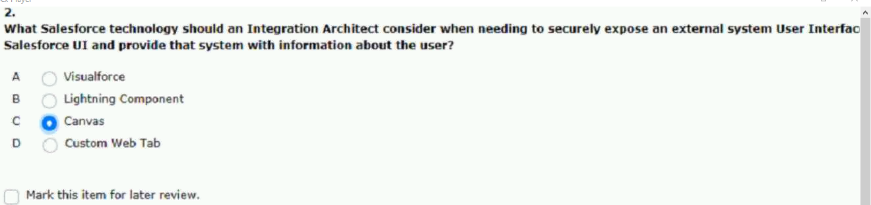

62.universal containers (uc) is planning to roll out a new lightning.
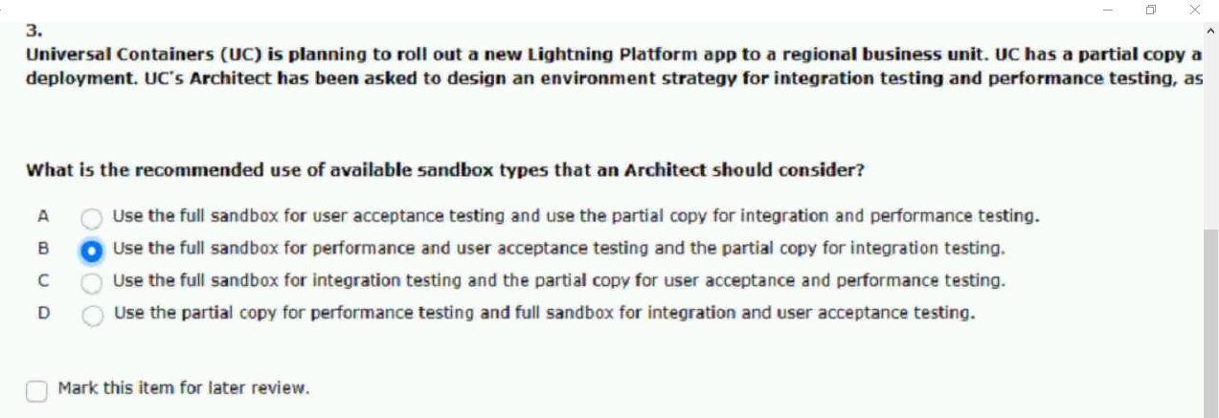
63.universal containers (us) is working with multiple partners to get.
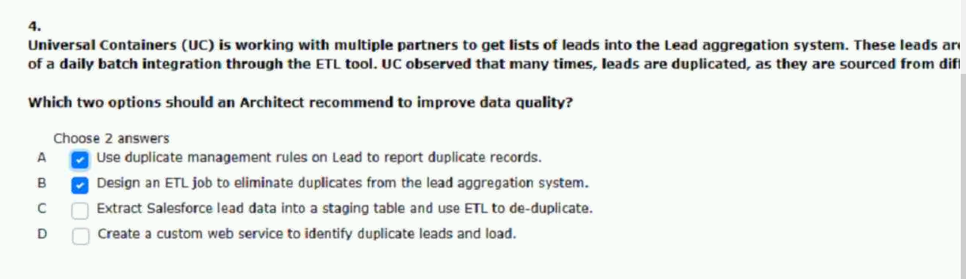
64.which two automated methods should an architect use.
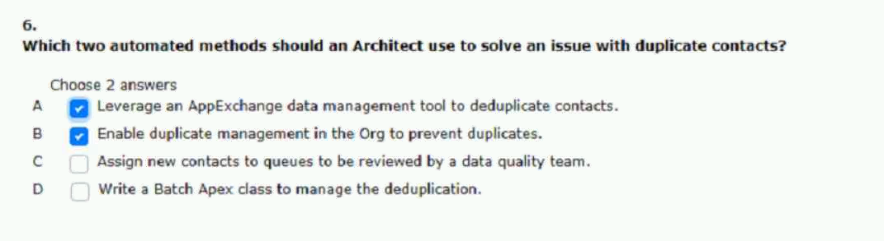

65.universal containers is implementing salesforce including a new
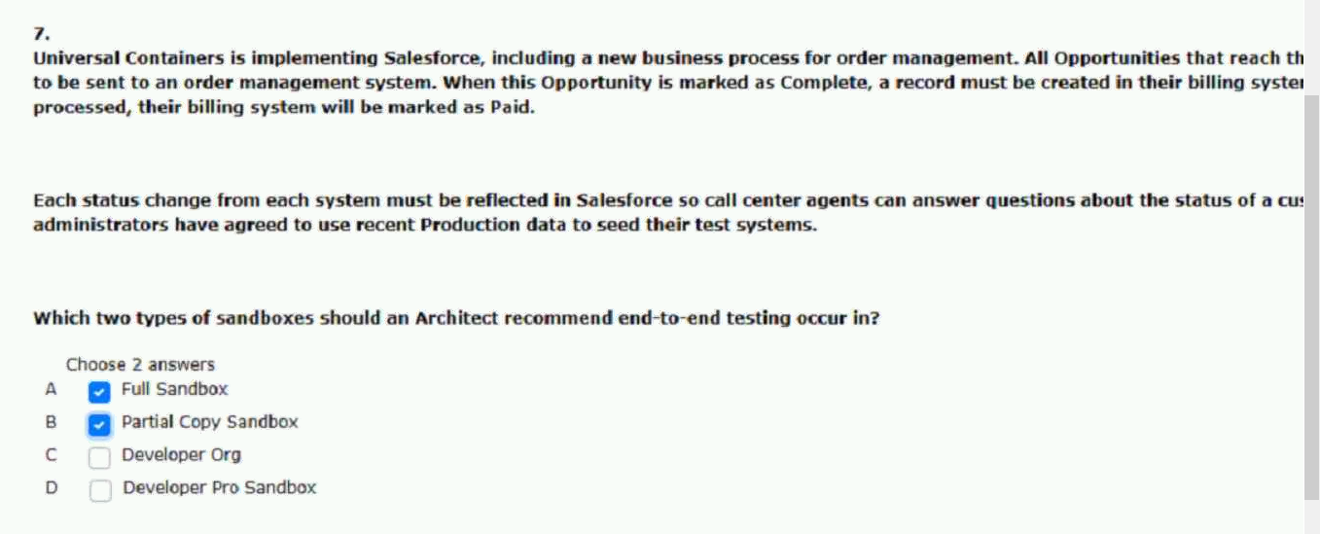
66.universal containers would like to send all the closed opportunity records.
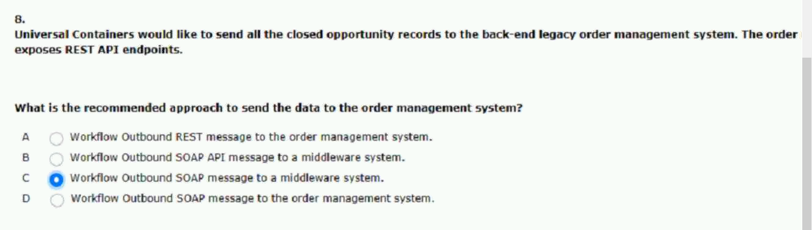
67.universal containers is hearing complaints from users that recently.
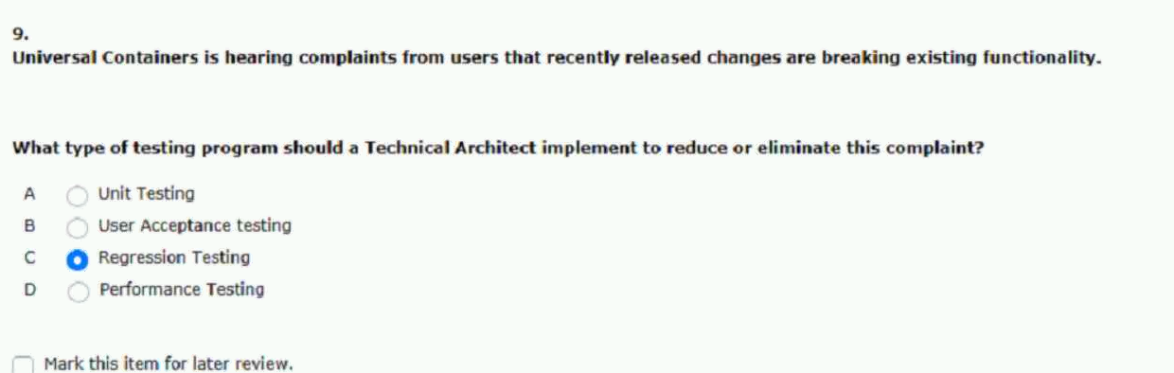

68.universal containers (uc) uses several systems as part of their enterprise.

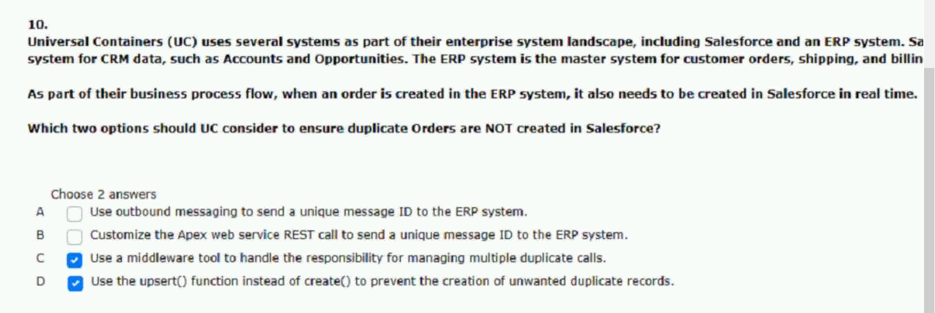
69.universal containers would like to use a hard-coded username.
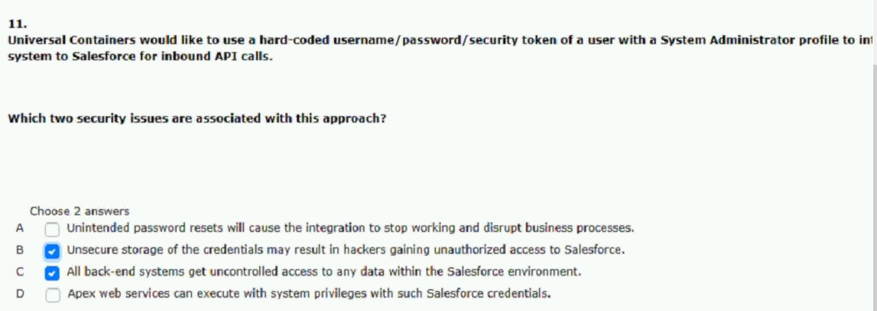
70.universal containers has a simple on-primes web app
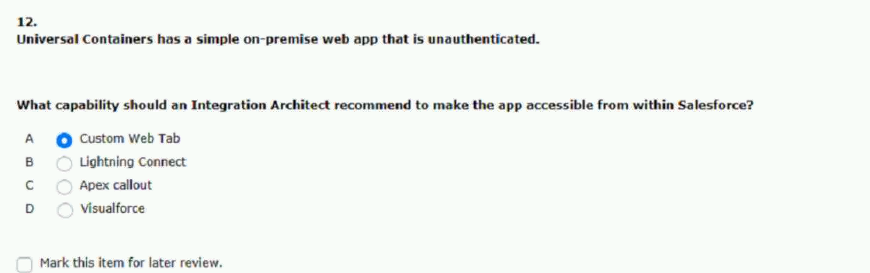

71.an insurance company decides to build an online portal using.
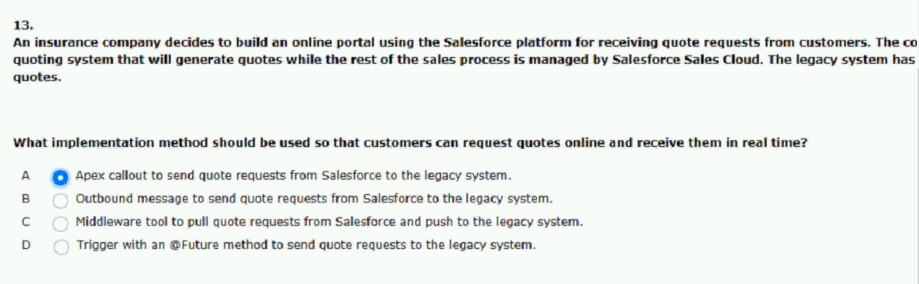
72.when an opportunity is closed in salesforce an order should be created.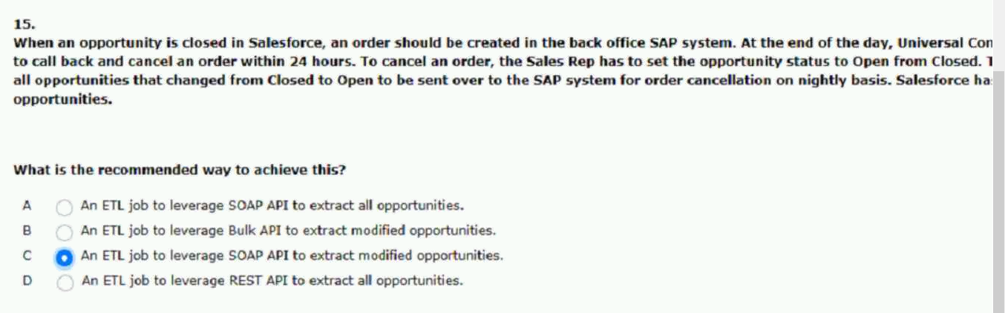
73.universal containers (uc) manager all of their customer.
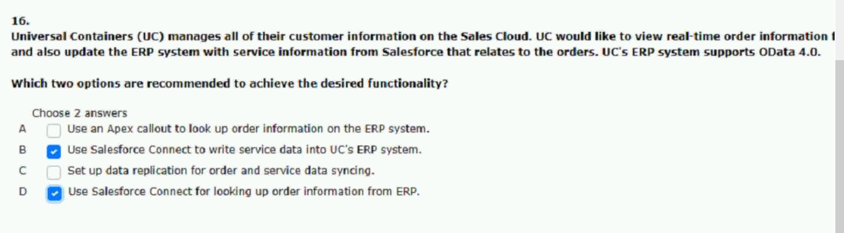

74.universal containers (uc) ships millions of orders per year.
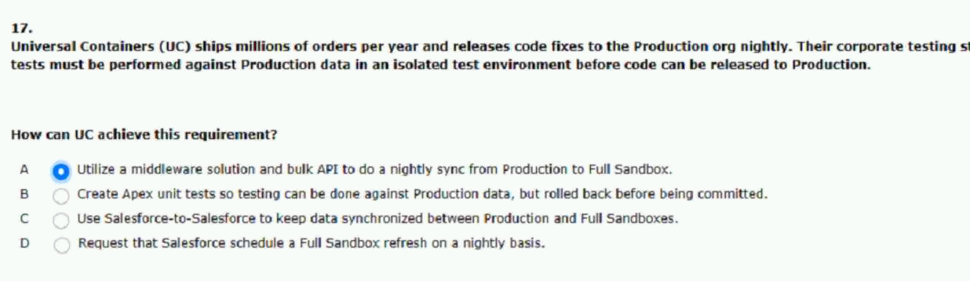
75.universal containers sells its products online using a system
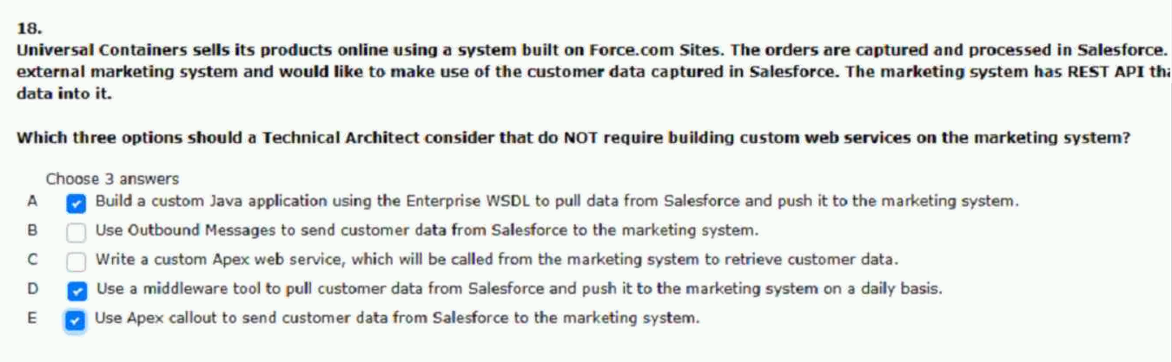
76.universal containers has decided that they will be using the bulk.
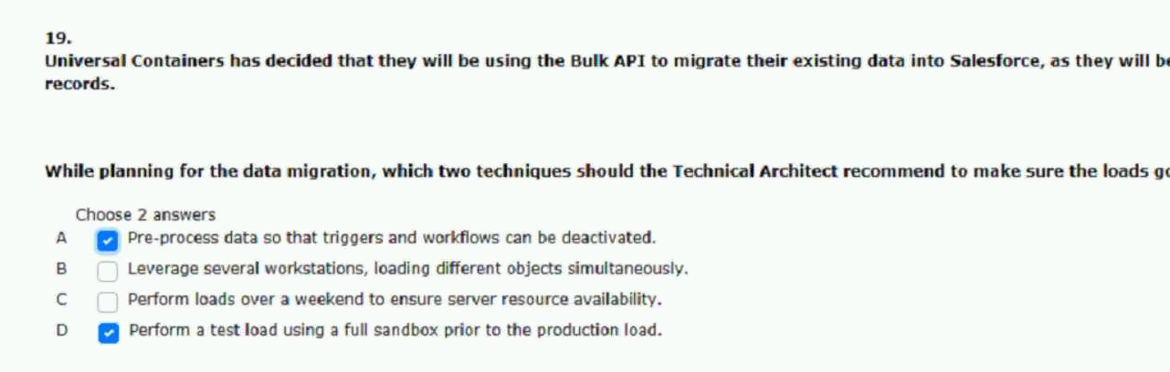

77.when making an apex callout what approach should an integration.
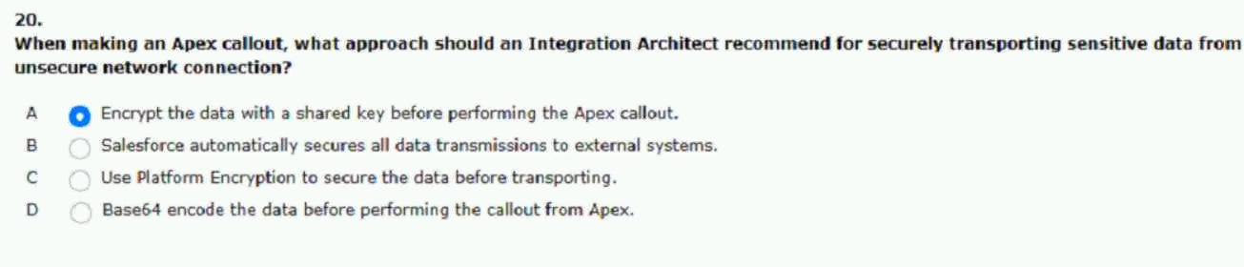
78.which two api options should be considered to permit automatic.
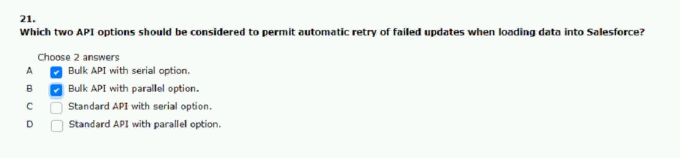
79.what capability should an integration architect consider if these is a need.
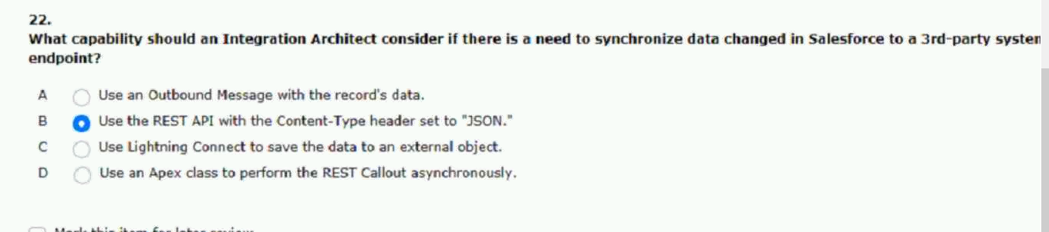
80.what tool would an architect likely leverage while diagnosing issues with.81.

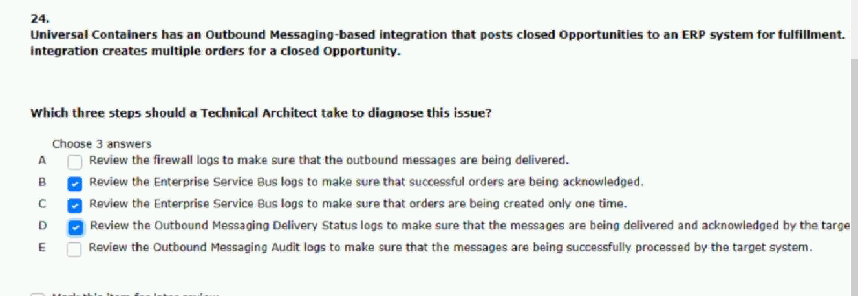
82.universal containers is building a mobile application that.
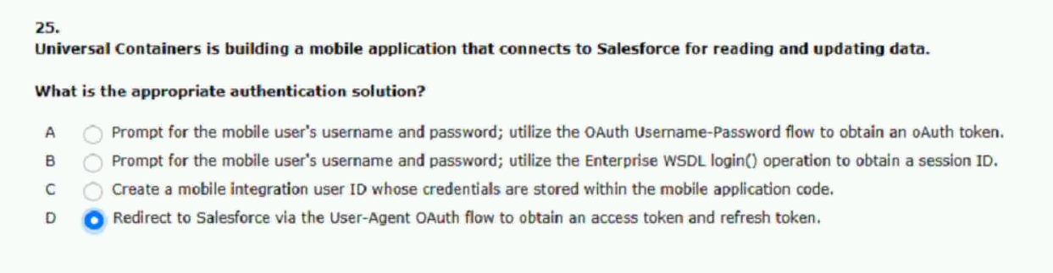
83.universal containers (uc) uses several systems as part of their enterprises.
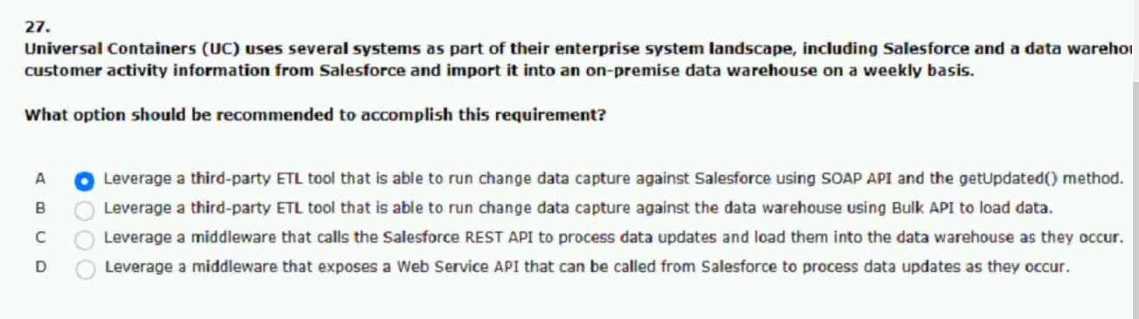
84.universal containers has just purchased a large volume of contact.
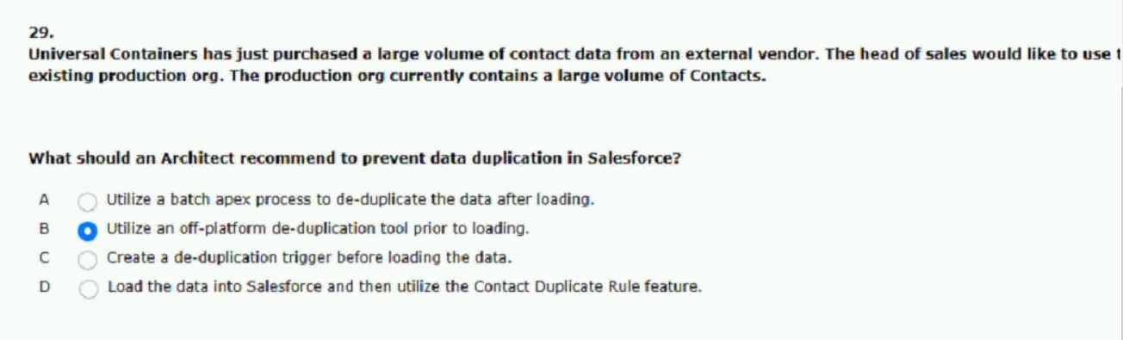

85.which two benefits should an integration architect consider.
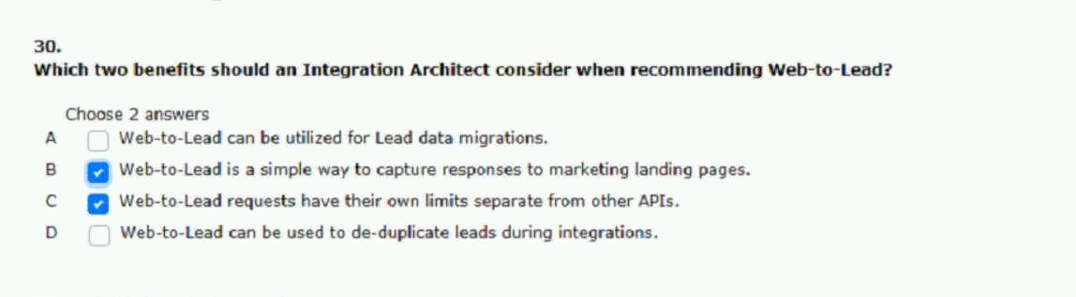
86.universal containers has a soap-based integration that runs nightly to.
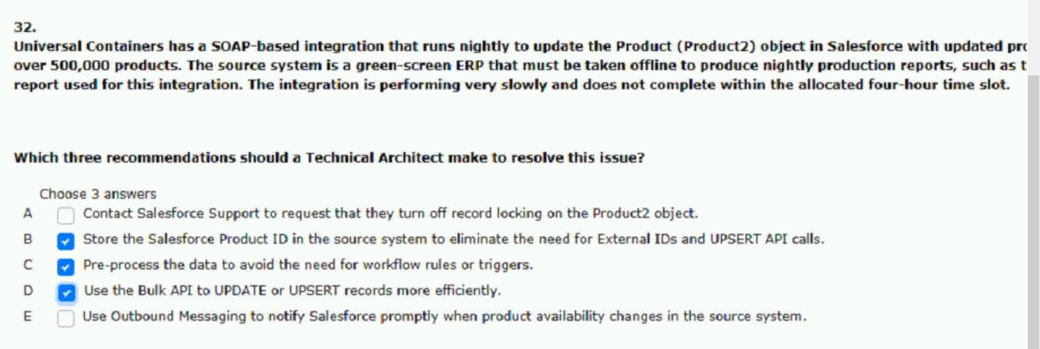
87.universal containers is replacing a home-grown crm system.
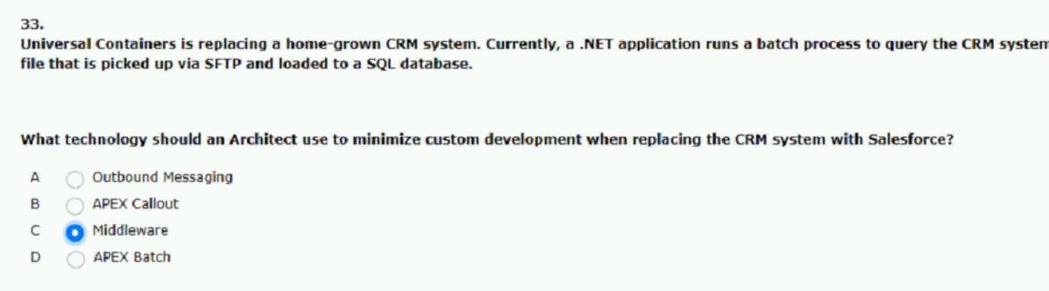

88.universal containers wishes to move data between three back.
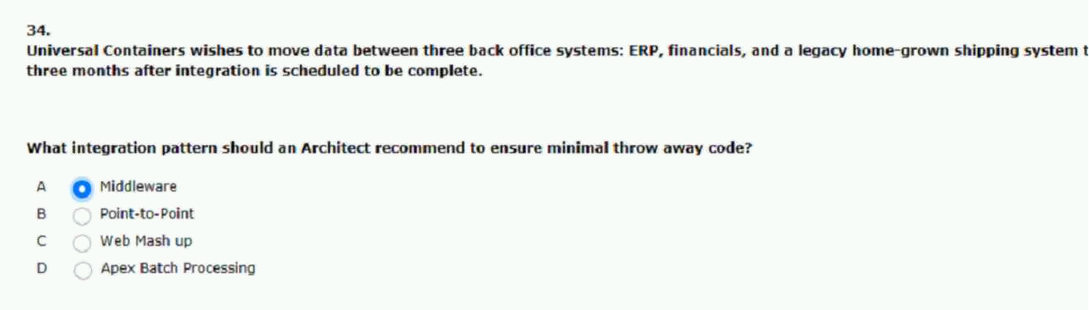
89.when a sales rep closes an opportunity in salesforce an order.
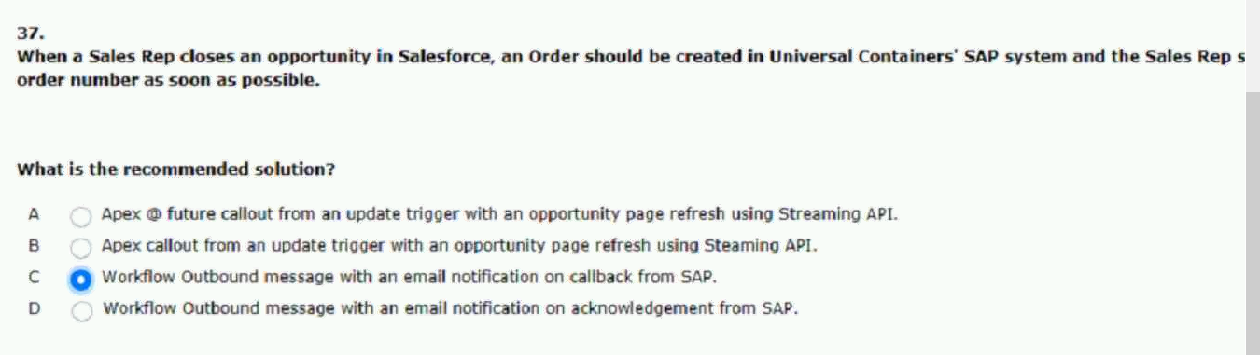
90.which two considerations should be made when performing.
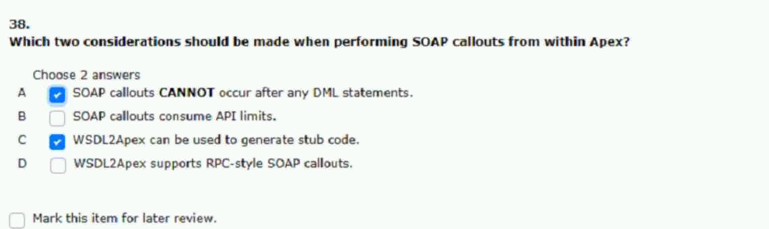

91.universal containers is using sales cloud with order capture.
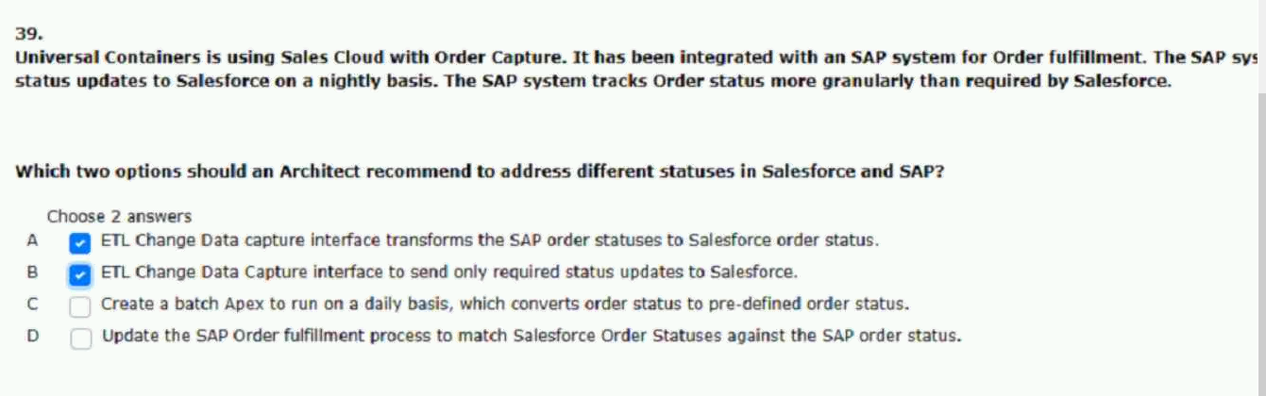
92.what protocol should an integration architect utilize.
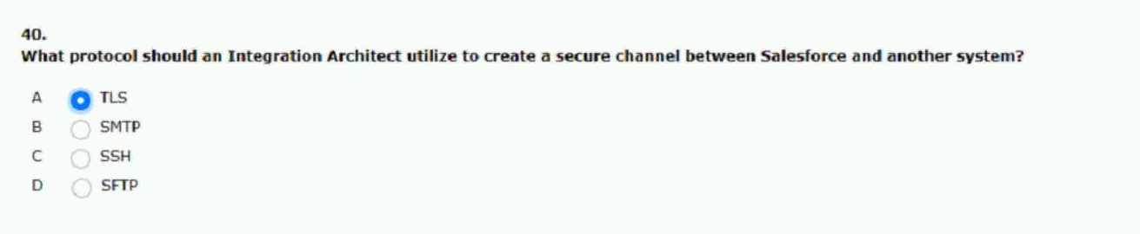
93.universal containers (uc) has a custom lead generation mobile.
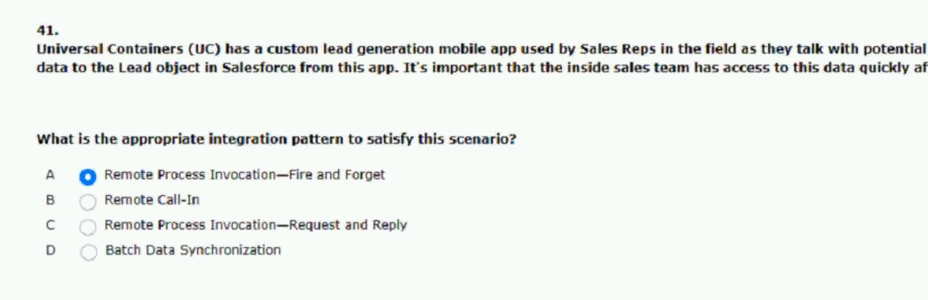

94.universal containers is planning to develop a native.
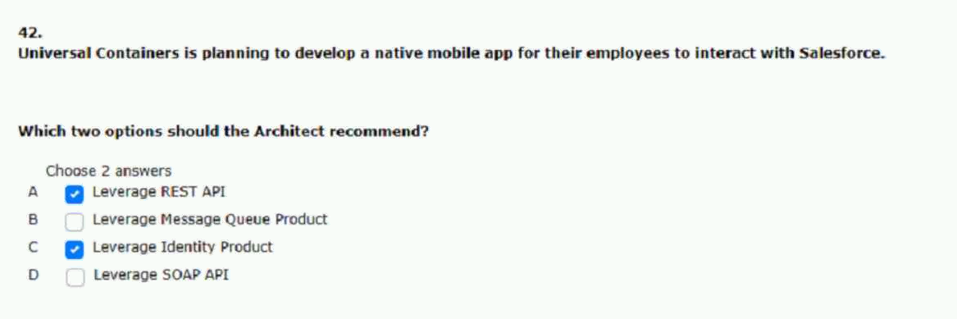
95.universal containers would like to integrate to an external system.
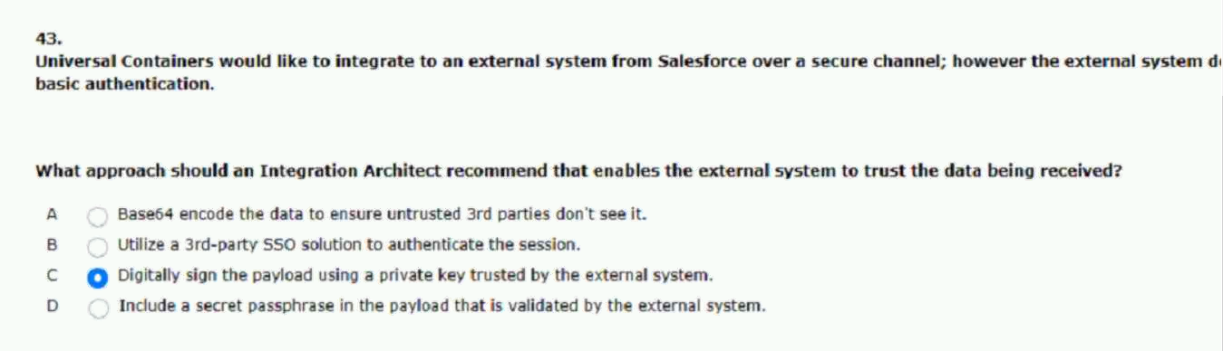
96.universal containers requires salesforce to send expense to an.
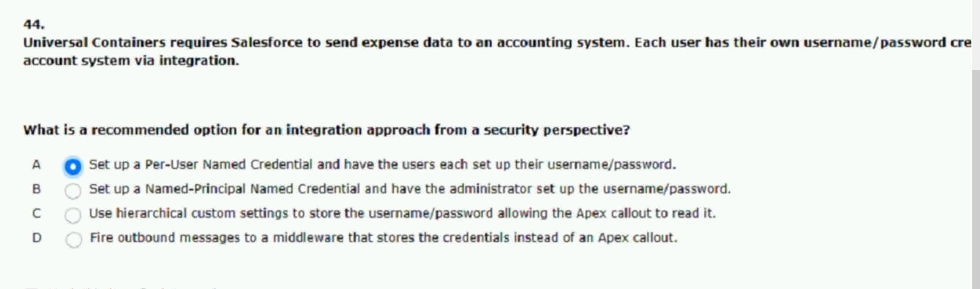

97.universal containers has used outbound messaging to integration with their.
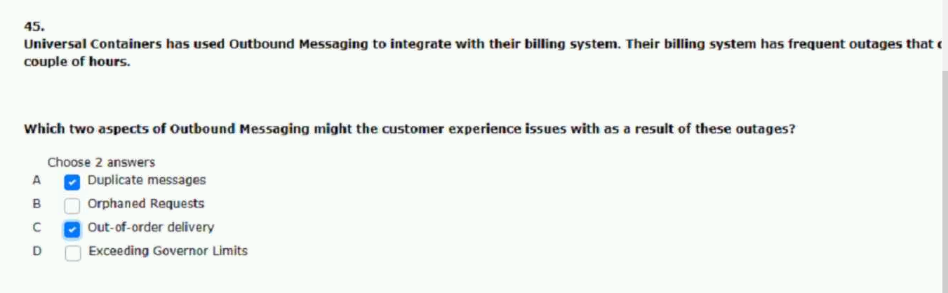
98.universal containers has a requirement to update the salesforce account.
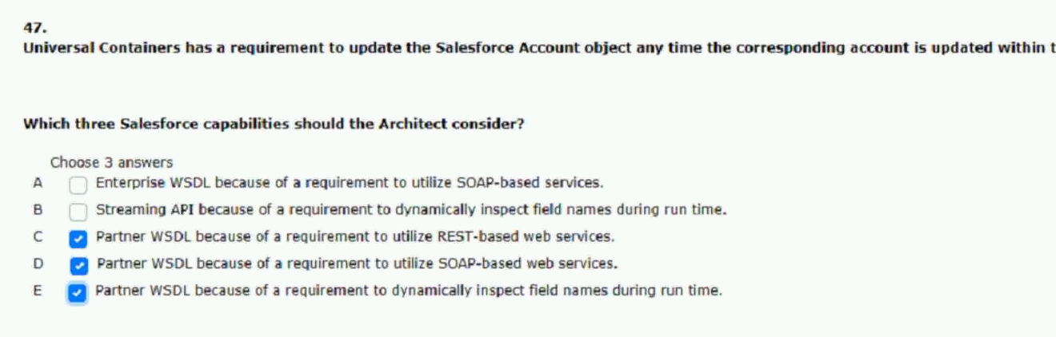
99.universal containers (uc) stores inventory of products in one salesforce.
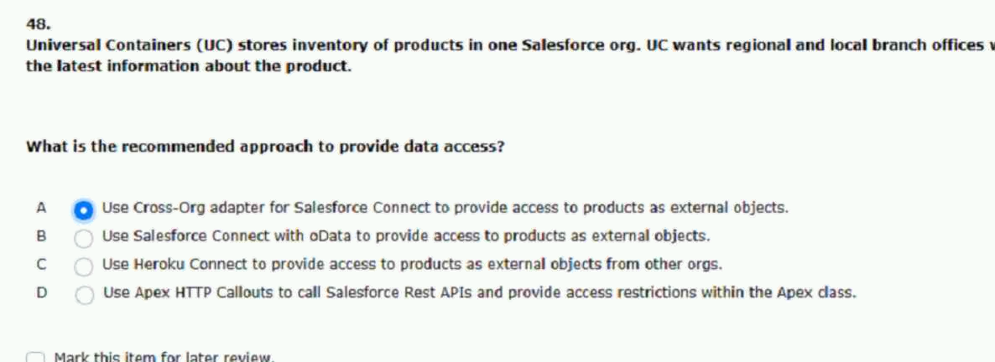

100.universal containers is building an integration between salesforce.
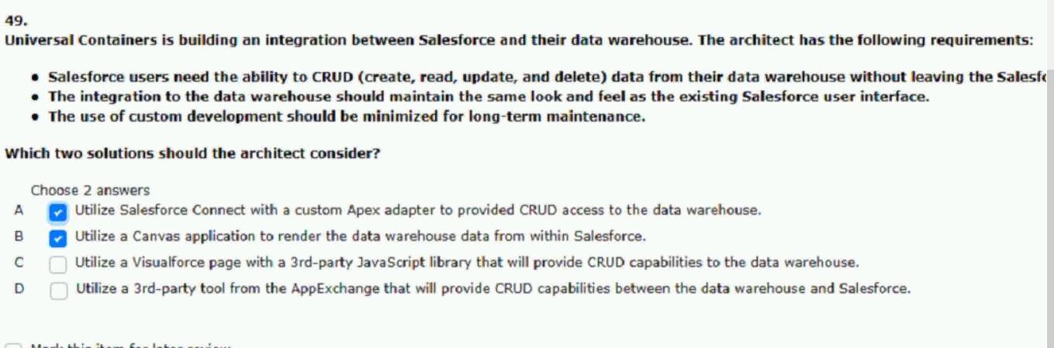
101.universal containers would like to update their accounting system every.
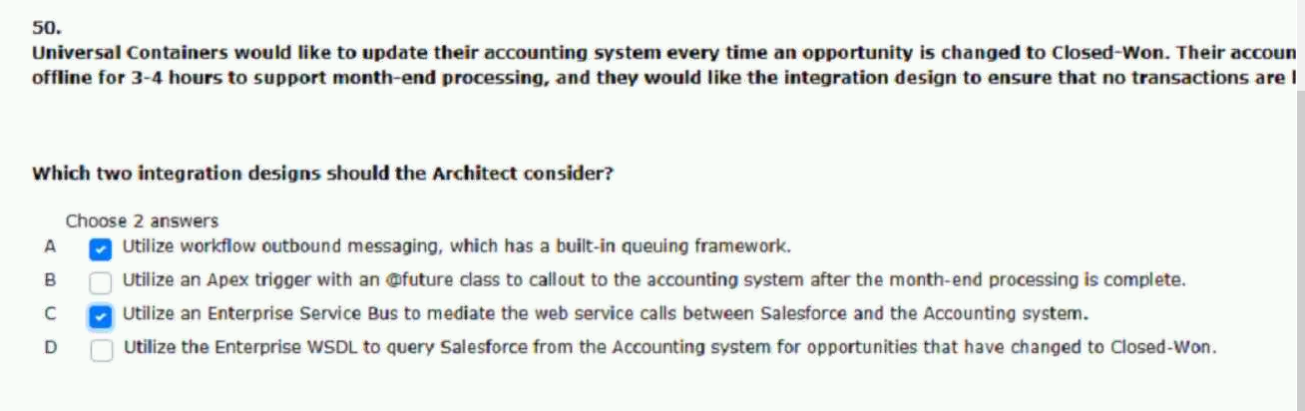
102.universal containers has 1,200 active users up until last year.
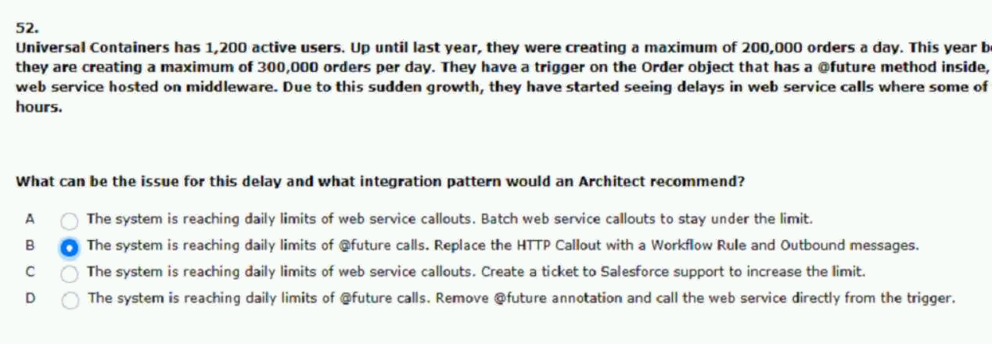

103.universal containers uses a legacy system to receive and handle.
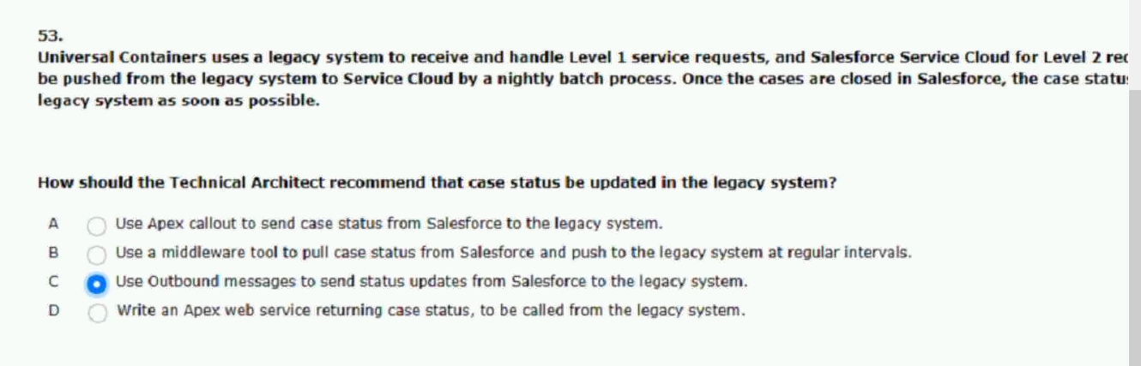
104.universal containers (uc) has integration developed between salesforce.
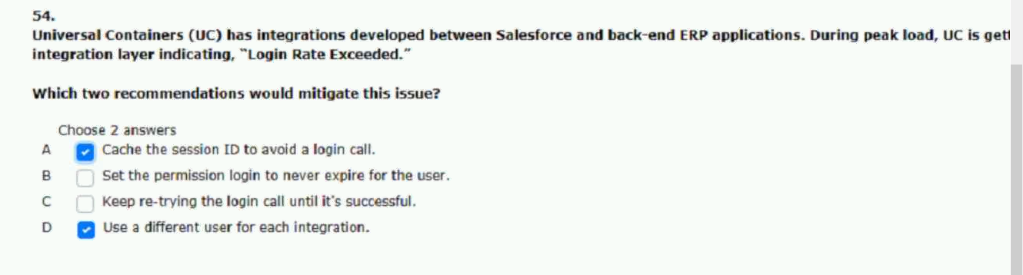
105.universal containers (uc) admin has installed a canvas app.
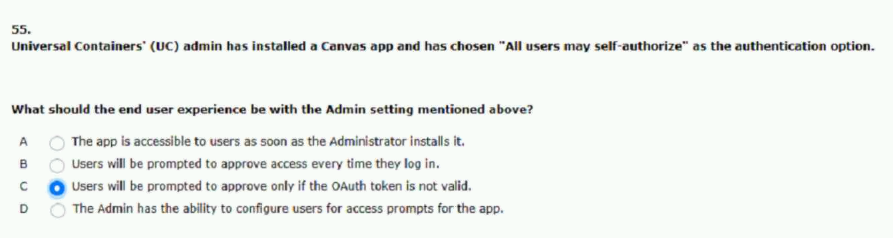

106.universal containers (uc) would like to provide near real-time updates on their.
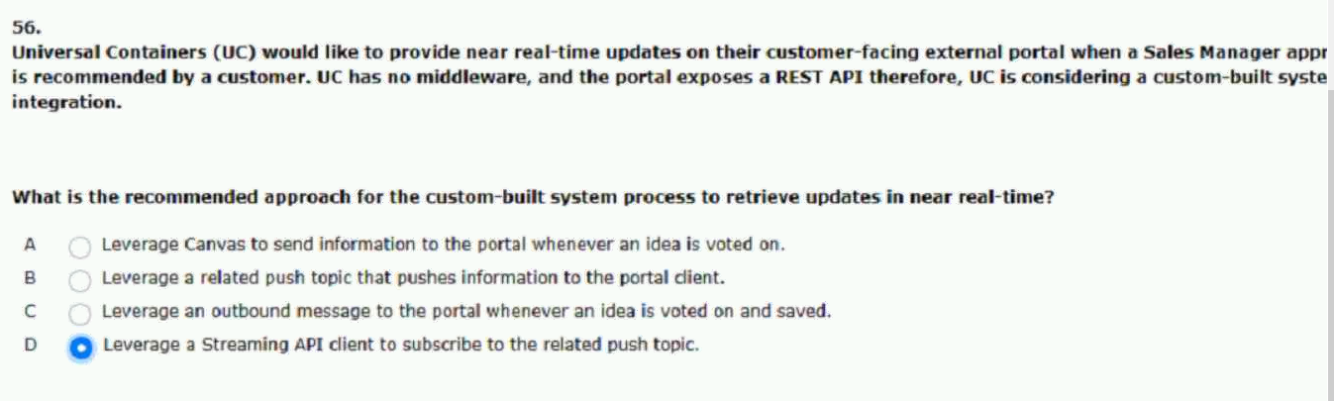
107.universal containers leverages sales cloud as their sales platform.
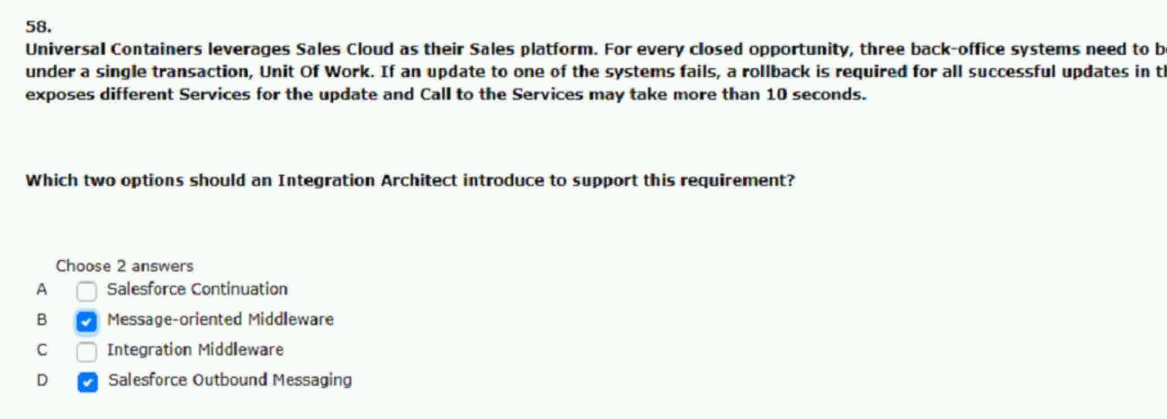
108.universal containers is planning a data migration into salesforce.
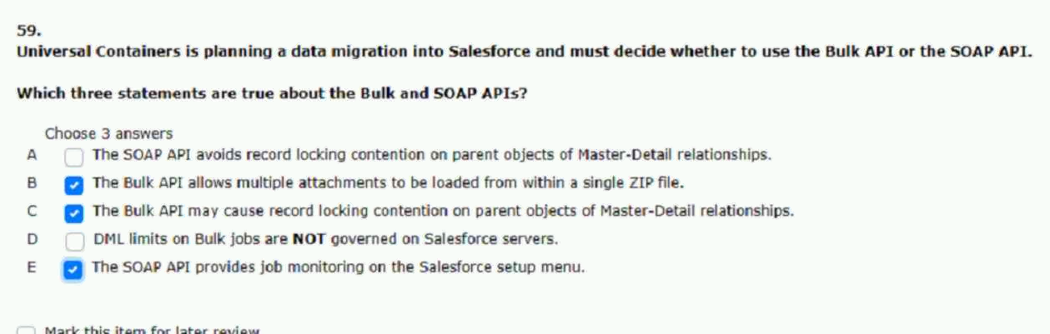

109.universal containers has a call center that would like to have.
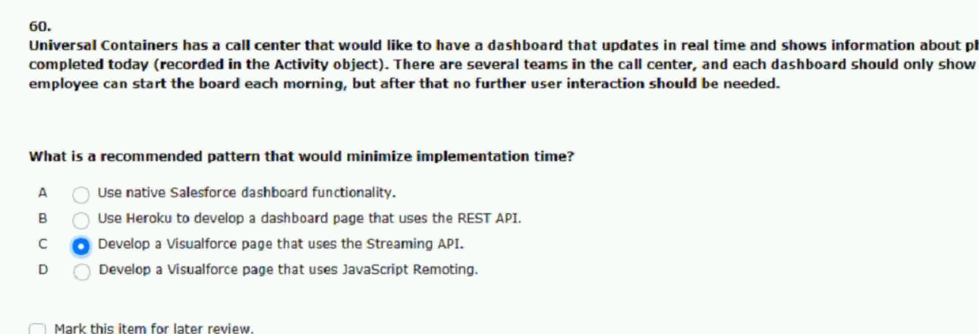
110.universal containers is building an integration between salesforce and their.
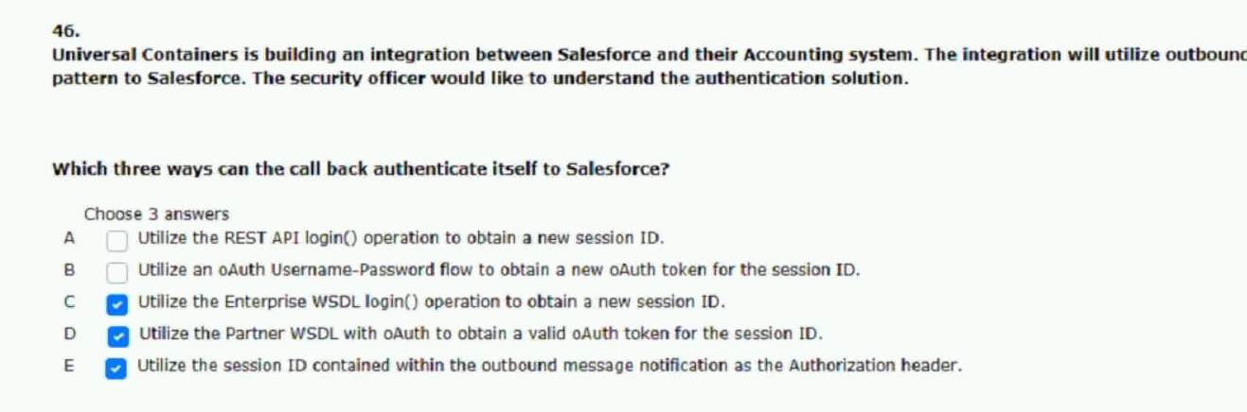
111.universal containers is building a managed package to distribute on the appexchange.

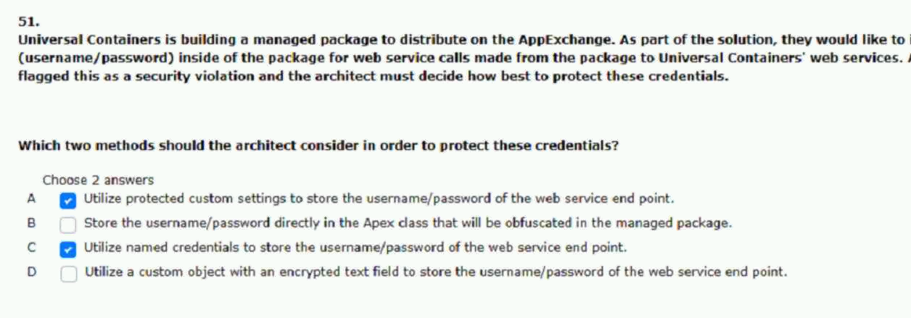

112.universal containers wants to send order information to a third-party.
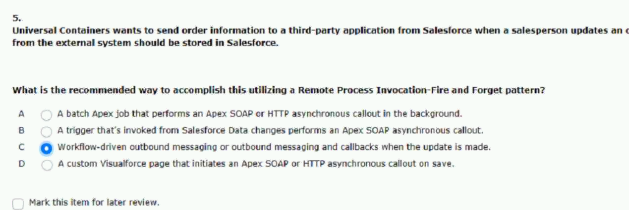
113.universal containers is managing their leads in salesforce.
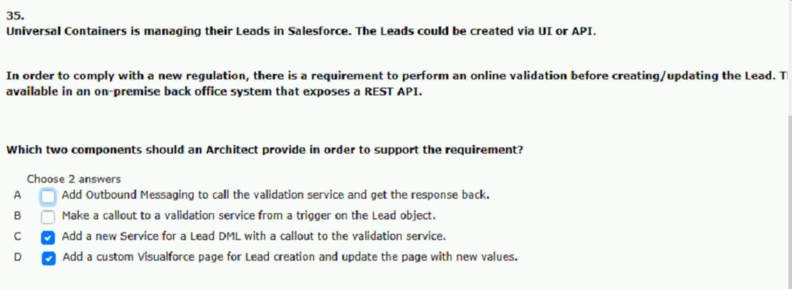
114.universal containers would like to display data from an external.
